July 28, 2024
Seventeenth Sunday in Ordinary Time


Mass Intentions / Peticiones de Misa

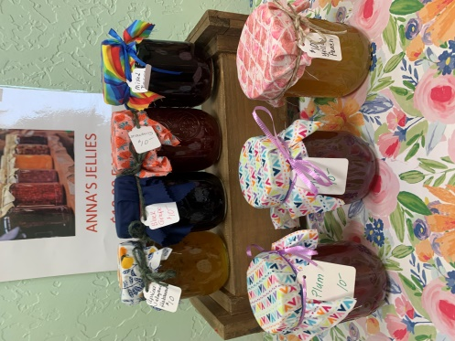
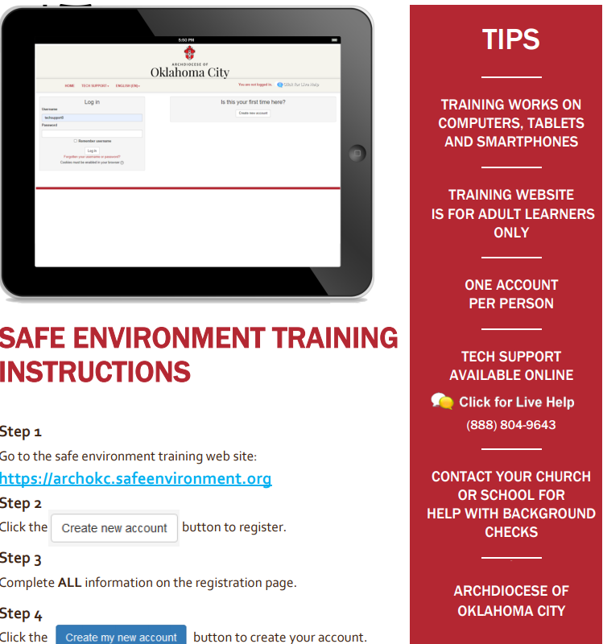

Saturday | Jul 27 | 6:00p D | (+) Troy Boice
Sunday | Jul 28 | 8:00a M | NO MASS
 |  | 10:00a D | NO MASS
 |  | 6:00p D | (+) Troy Boice
 |  |  | (+) Noe Almeida, Jr.
Monday | Jul 29 | 6:00p D | NO MASS
Tuesday | Jul 30 | 6:00p D | (+) Troy Boice
Wednesday | Jul 31 | 6:00p D | Special Intention
Thursday | Aug 1 | 12:10p D | (+) Susie Walton
Friday | Aug 2 | 12:10p D | (+) Susie Walton

Congratuations Rev. Peter Jandaczek,
Our pastor
on the Jubilee Celebration of your
25th year of Priestly Ordination.

HEALING MASS,
THURSDAY, APRIL 11, 2019
at 7 p.m.
Assumption Catholic Church

MISA DE SANACION
Jueves 11 de April del 2019
a las 7 p.m.
HEALING MASS,
THURSDAY, APRIL 11, 2019
at 7 p.m.
Assumption Catholic Church

MISA DE SANACION
Jueves 11 de April del 2019
a las 7 p.m.
HEALING MASS,
THURSDAY, APRIL 11, 2019
at 7 p.m.
Assumption Catholic Church

MISA DE SANACION
Jueves 11 de April del 2019
a las 7 p.m.

Immaculate Conception
has been moved to

Monday, December 9.
There is only one Mass
At Marlow at 7 p.m.

The Feast of the Assumption of the Blessed Virgin Mary
Is a Holy Day of Obligation and celebrated on
Thursday, August 15, 2023.
There is only one bilingual mass At 6 p.m.

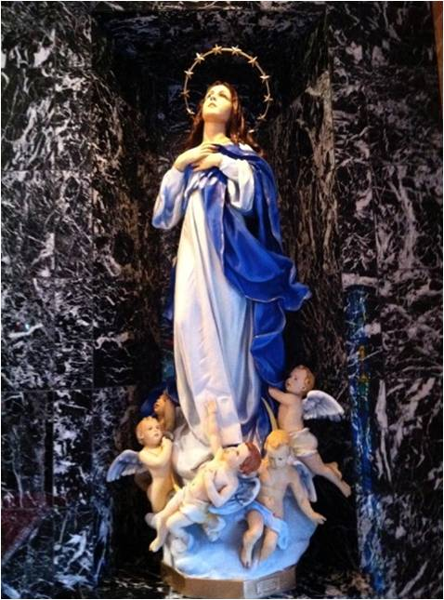

Abuse of Minors Response Hotline 405-720-987 or DHS at 1-800-522-3511.
Telefóno Pastoral para Reportar Abuso de Menores 405-720-9878 o el Departamento de Servicios Humanos 1-800-522-3511.

August 4, 2024
Eighteenth Sunday in Ordinary Time

Mass Intentions / Peticiones de Misa

Saturday | Aug 3 | 6:00p D | (+) Susie Walton
Sunday | Aug 4 | 8:00a M | For the Parishioners
 |  | 10:00a D | (+) Susie Walton
 |  | 12:00p D | Special Intention
Monday | Aug 5 | 6:00p D | (+) Susie Walton
Tuesday | Aug 6 | 6:00p D | (+) Susie Walton
Wednesday | Aug 7 | 6:00p D | (+) Susie Walton
Thursday | Aug 8 | 12:10p D | (+) Susie Walton
Friday | Aug 9 | 12:10p D | (+) Susie Walton
Saturday | Aug 10 | 6:00p D | (+) Susie Walton
Sunday | Aug 11 | 8:00a M | (+) Edgar Jones
 |  | 10:00a D | (+) Susie Walton
 |  | 12:00p D | (+) Salvador Galvez Macias and  (+) Gilberto Ortega



Talitha Koum
A women’s discernment retreat for women ages 15-30 will be held Aug. 4-6 at Our Lady of Guadalupe Catholic Camp in Wellston. Register at archokc.campbrainregistration.com
ATTENTION: ALL YOU COOKS AND BAKERS!!!
Please get your recipes together for a Church Cookbook.
If you have questions or want to submit recipes
(either handwritten or by email) please contact:
Susan Evans at 580-251-0956, nannysusie.evans@yahoo.com
or Julie McKinney at 580-641-2974 mckinneypeace@gmail.com
Recipe format:
1. Title: bold print;
2. Ingredient with amount;
3. Include temperature;
4. Directions;
5. Name, a short description/story;
6. Need phone number (not to be be published) with recipe’s owner
Note: no recipe pictures included

Are you or someone you love in need of counseling services?
We’re here to help! Please give us a call at
405-524-0969 for more information.
Abuse of Minors Response Hotline 405-720-987 or DHS at 1-800-522-3511.
Telefóno Pastoral para Reportar Abuso de Menores 405-720-9878 o el Departamento de Servicios Humanos 1-800-522-3511.

Assumption of the BVM
Collections: Saturday-Sunday, July 14 & 21:
General: $2,187.00/$2,481.00
Building: $386.00/$563.00
Weekly Automatic Donations: $1,100.00
Immaculate Conception of the BVM
Collections: Sunday, July 14 & 21:
General: $927.00/$1,307.00
Building Fund: $856.00/$270.00

AUTOMATIC DONATION
Did you Know: You can always donate via automatic withdrawal directly to our church's account. It is easy, simple and at the end of the fiscal year you will receive a tax letter acknowledging your donations. For more information stop by the office after each Mass.
Thank you for your support.

