Sixth Sunday of Easter
May 6, 2018

Lordy, Lordy
Fr. David is 40!

Come and join us for his
40th birthday party on
Thursday, May 10 at 7 p.m. in Gillespie Hall with a
Pot Luck Dinner
Meat, drinks and bread
will be provided
by the Duncan & Marlow
Altar Society
Please bring the following
to share
according to your last name:

A – I Main Dish: Casseroles, etc.
J – R Side Dish: Vegetables, salads
S – Z Dessert, fruit, sweets, etc.
Mass Intentions / Peticiones de Misa

Sat | May 5 | 4:00p D | (+) Cindi Broaddus by  Bennie & Shannon Wilson
 |  | 6:00p R | For the Parishioners
Sun | May 6 | 8:00a M | (+) Easton Peterson by KofC
 |  | 10:00a D | (+) Howard Doerr by Janet Deeg
 |  | 12:00a W | For Little Victoria on her Birthday
 |  | 2:00p D | NO MASS
Mon | May 7 | 12:10p D | (+) Marius Deasy by Gail Boehm
Tues | May 8 | 12:10p D | (+) Marius Deasy by Gail Boehm
Wed | May 9 | 12:10p D | For Urula’s Good Health
Thur | May 10 | 12:10p D | (+) Marius Deasy by Gail Boehm
Fri | May 11 | 12:10p D | (+) Marius Deasy by Gail Boehm
Sat | May 12 | 4:00p D | (+) George E. Coughlin
 |  | 6:00p R | For the Parishioners
Sun | May 13 | 8:00a M | (+) Easton Peterson by KofC
 |  | 10:00a D | For all Living & Deceased Mothers
 |  | 12:00p W | (+) Henry Renschen
 |  | 2:00p D

Special Collection for Property and Liability Insurance
BALANCE TO COLLECT: $6,500.00
Every Sunday we will be having a Second Collection
for our Property and Liability Insurance for the year
2018/2019 which is around $19,000.00.
Therefore, we request that you help $12,500.00
us to raise money for this necessary expenditure.
Please write checks to
Assumption/Building Fund. $5,000.00
Thank you for your generosity.
May God Bless You, Fr. Peter $2,000.00

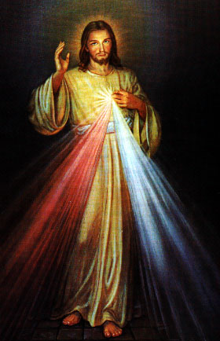
Third Annual Christmas Bazaar
November 20, 21 and 22
Attention: There will be a work day on Saturday, October 10 at 10 a.m. in Gillespie Hall! We need your ideas! It will take all of us participating to make our Bazaar a success!!!

Eggrolls by Agnes, order now.
She will only make 20 dozen.
They are $40 per dozen.
Pick up will be Friday, October 16.
Place order and pay at the office.

Order Tamales by Carmen
at $25.00 per dozen.
Order and pay at the office.
Pick up will be
Saturday, Nov 14.

The profit will equally be divided between three Parishes: Walters, Duncan and Marlow for the purpose of the building fund. We need your time, talent and treasure to make this event successful.

Abuse of Minors Response Hotline 405-720-987 or DHS at 1-800-522-3511.
Telefóno Pastoral para Reportar Abuso de Menores 405-720-9878 o el Departamento de Servicios Humanos 1-800-522-3511.


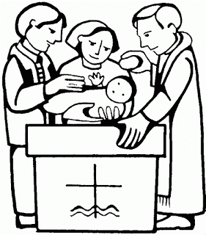

Platicas del Sacramento de Bautizmo
en Español
Mayo 26, Agosto 18, Noviembre 10, Son a la 7 p.m. en La capilla.
Para mas informacioń
llame a la oficina
580-255-0590 ex 11,
o Carmen Garcia 580-255-6337 Gracias

DUNCAN ALTAR SOCIETY MEETING,
WEDNESDAY, MAY 16
after 12:10 p.m. Mass.
Bring a dish to share for a
pot luck lunch.

Mark your calendar for Catholic Foundation’s presentation on wills and trusts. This will be held on Monday, October 24 at 7 p.m. at Assumption Catholic Church Gillespie Hall. Come and learn how to take care of those you love.
You can have a Mass said for someone's intentions at their birthday, wedding, baptism, or in memory of your deceased loved ones. Contact he office for days and times that you wish to have the Mass celebrated. What a precious gift!

ANNUAL GUADALUPE GARAGE SALE
COMING SOON!!!
If you have items to pick up please call
Noe Sanchez 475-4892, Maria Jones 467-8794 or Carmen Garcia 255-6337

Esperamos Donaciones
Para Annual Garage Sale
Muebles, ropa, jugueter trastes, etc.
Gracias por su generosidad.

Register now for Catholic Summer Camp
The mission of Our Lady of Guadalupe Catholic Youth Camp is to nurture positive Catholic values in young people and to provide campers a community of faith and fun in a safe environment. Each session begins on Sunday with registration 5-6 p.m. and ends on Friday with pick-up 4-5 p.m. www.archokc.org/camp.



DUNCAN COLLECTIONs FOR
APRIL 28-29:
Duncan: $1,735.00
Weekly Electronic Donations: $1,200.00
Building Fund: $631.00
Thank you for your generosity!!!

Catholic Young Adults of OKC
Open to all young adults (ages 18-39, married or single) in the archdiocese. Visit our Facebook page (Catholic Young Adults of OKC) for events and information or e-mail info@catholicyoungadultsokc.com.

The Gift of Love Gala
The Center of Family Love and Knights of Columbus will host The Gift of Love Gala at 6 p.m. June 16 at the National Cowboy and Western Heritage museum. Single ticket $175. Black tie optional. Visit centeroffamilylove.org.

Immaculate Conception Church
Marlow
*********************************
Collections:
Apr 29: General-$582.00

Join Archbishop Coakley to Pray!
Archbishop Coakley is asking for parishioners to sign up to pray for the future of the diocese and for guidance as he moves forward with pastoral planning through 2030. To join the 2018 Prayer Team, text Prayer2018 to 84576 or go to https://app.flocknote.com/archokc/2018Intercessory.

Saint Patrick Catholic Church
Walters, Oklahoma 73572
********************************
Collections:
Apr 22: Operating $374.00
Apr 29: Operating $350.45
Building Fund: $125.00

