Palm Sunday of the Passion of the Lord
March 25, 2018

Assumption Parish
Holy Thursday, March 29, 7 p.m.
Good Friday, March 30, 7 p.m.
Holy Saturday, March 31, 7 p.m.

Mass Intentions / Peticiones de Misa

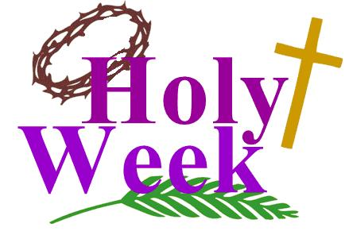
Sat | Mar 24 | 4:00p D | (+) Paul
 |  | 6:00p R | For the Parishioners | Christmas Bazaar  Our Christmas Bazaar  will be held  November 18, 19 and 20.  We hope everyone is making  beautiful items for sale.  There will also be a raffle for  three Visa cards:  $1,000, $500 and $250!  The raffle tickets are for sale now!  They are $5.00 each or five for $20.00! Please buy tickets and  also check them out to sell.  Let’s come together and  work hard to make this a  successful event!
Sun | Mar 25 | 8:00a M | Living and Deceased Members of the Altar Society
 |  | 10:00a D | (+) Grandparents
 |  | 12:00p W | (+) Aldine Maier
 |  | 2:00p D | (+) Virginia Rivera by the Family
Mon | Mar 26 | 12:10p D | NO MASS
Tues | Mar 27 | 12:10p D | NO MASS
Wed | Mar 28 | 12:10p D
Thur | Mar 29 | 7:00p D | HOLY THURSDAY
Fri | Mar 30 | 7:00p D | GOOD FRIDAY  Our Easter Sunday Schedule  Marlow 8 a.m.  Duncan 10 a.m.  Walters 10 a.m.  No tenemos la misa en español a las 2 p.m.
Sat | Mar 31 | 7:00p D | HOLY SATURDAY
Sun | Apr 1 | 8:00a D |   (+) Myrtle Wooldridge
 |  | 10:00a D | For the Parishioners
 |  | 10:00p W | (+) Howard Doerr by Janet Deeg
 |  | 2:00p D | NO MASS
ATTENTION CHILDREN:
On Easter Sunday, April 1 after
Assumption’s 10 a.m. Mass there will be an
EASTER EGG HUNT
sponsored by the Knights of Columbus.

PLEASE NOTICE: There will be no Daily 12:10 p.m. Mass
Monday or Tuesday, March 26-27.

Special Collection for Property and Liability Insurance
BALANCE TO COLLECT: $8,000.00
Every Sunday we will be having a Second Collection
for our Property and Liability Insurance for the year
2018/2019 which is around $19,000.00.
Therefore, we request that you help $11,000.00
us to raise money for this necessary expenditure.
Please write checks to
Assumption/Building Fund. $5,000.00
Thank you for your generosity.
May God Bless You, Fr. Peter $2,000.00

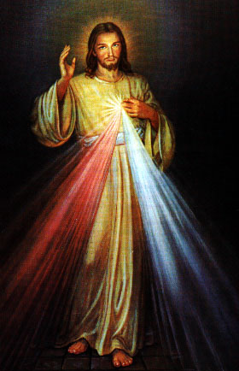
Third Annual Christmas Bazaar
November 20, 21 and 22
Attention: There will be a work day on Saturday, October 10 at 10 a.m. in Gillespie Hall! We need your ideas! It will take all of us participating to make our Bazaar a success!!!

Eggrolls by Agnes, order now.
She will only make 20 dozen.
They are $40 per dozen.
Pick up will be Friday, October 16.
Place order and pay at the office.

Order Tamales by Carmen
at $25.00 per dozen.
Order and pay at the office.
Pick up will be
Saturday, Nov 14.

The profit will equally be divided between three Parishes: Walters, Duncan and Marlow for the purpose of the building fund. We need your time, talent and treasure to make this event successful.

Abuse of Minors Response Hotline 405-720-987 or DHS at 1-800-522-3511.
Telefóno Pastoral para Reportar Abuso de Menores 405-720-9878 o el Departamento de Servicios Humanos 1-800-522-3511.


Religious Education (RE) Families:
Please note the following dates:
Sun, Mar 25 | NO CLASS PALM SUNDAY
Wed, Mar 28 | NO CLASS HOLY WEEK
Sun, Apr 1 | NO CLASS EASTER SUNDAY
Wed, Apr 4 | Class
Wed Apr 4 @ 6:30 pm | Confirmation Mass Practice  In Church
Sun, April 8, 2018 | NO CLASS  Confirmation Mass @ 10am
Wed, Apr 11 | Class
Sat, May 5, 2018 | First Communion Retreat/Reconciliation  @ 1:00-3:00 pm
Sun, May 6, 2018 | First Communion Mass @ 10am

Lenten Penance Service
Palm Sunday,
March 25
at 7 p.m.

Mark your calendar for Catholic Foundation’s presentation on wills and trusts. This will be held on Monday, October 24 at 7 p.m. at Assumption Catholic Church Gillespie Hall. Come and learn how to take care of those you love.
You can have a Mass said for someone's intentions at their birthday, wedding, baptism, or in memory of your deceased loved ones. Contact he office for days and times that you wish to have the Mass celebrated. What a precious gift!

Seder Meal
Immaculate Conception
Wednesday, March 28 at 6 p.m.
Please sign up prior to
Sunday, March 25 or call
Bill Havron at 580-512-6867.
There is a list of items
to bring contact
Bette Cooper at 580-641-1350



ANNUAL GUADALUPE GARAGE SALE
COMING SOON!!!
If you have items to pick up please call
Noe Sanchez 475-4892, Maria Jones 467-8794 or Carmen Garcia 255-6337

Esperamos Donaciones
Para Annual Garage Sale
Muebles, ropa, jugueter trastes, etc.
Gracias por su generosidad.


World Day of Prayer for Vocations
The 2018 World Day of Prayer for Vocations will be observed Sunday, April 22, also known as "Good Shepherd Sunday." The purpose of this day is to publicly fulfill the Lord's instruction to "Pray the Lord of the harvest to send laborers into his harvest" (Mt 9:38; Lk 10:2). Please pray that young men and women hear and respond generously to the Lord's call to the priesthood, diaconate, religious life, societies of apostolic life or secular institutes. Find many resources to promote a culture of vocations at www.usccb.org/vocations.

Immaculate Conception Church
Marlow
*********************************
Collections:
Mar 18: General-$1,149.00
Building: $65.00

SCHOLARSHIPS!!! - IT IS THAT TIME AGAIN
ASSUMPTION CATHOLIC CHURCH and the Knights of Columbus Council No. 5168 are again accepting applications for the Jesse Wayne Moore Scholarships for the graduating seniors wishing to further their education this year. A few scholarships, from $300 to $1,500 are available. You may obtain application forms from Jim Surjaatmadja or the Assumption Church Office and submit the applications and the necessary documents ON or BEORE Monday, April 23, 2018 to the Church's office or myself. All applications will be judged on Parish activities, community activities and scholastic achievements. A note to all Parish Members: On behalf of the Knights and the graduating Seniors, we would like to thank everyone for the generous contributions that help make the Scholarship Program continue throughout the years. But, we will need your support again for the years to come. For this, again we will ask your continued generous monthly contributions. Please write your checks to Assumption Church Scholarship Fund. Thank you again for your continuing support! Jim Surjaatmadja, Scholarship Chairman, Knights of Columbus 5168.

Saint Patrick Catholic Church
Walters, Oklahoma 73572
********************************
Collections:
Mar 18: Operating $369.00
Building Fund: $165.00

DUNCAN COLLECTIONs FOR
Mar 17-18:
Duncan: $1,676.00
Weekly Electronic Donations: $1,200.00
Building Fund: $598.00
St. Vincent de Paul: $31.00
Food Bank: $12.00
Ryan: $70.00
Thank you for your generosity!!!

