Fourth Sunday of Lent
March 11, 2018

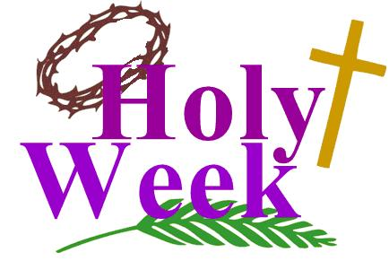

Assumption Parish
Holy Thursday, March 29, 7 p.m.
Good Friday, March 30, 7 p.m.
Holy Saturday, March 31, 7 p.m.

Mass Intentions / Peticiones de Misa

Sat | Mar 10 | 4:00p D | (+) Janis Wald
 |  | 6:00p R | (+) Aldine Maier | Christmas Bazaar  Our Christmas Bazaar  will be held  November 18, 19 and 20.  We hope everyone is making  beautiful items for sale.  There will also be a raffle for  three Visa cards:  $1,000, $500 and $250!  The raffle tickets are for sale now!  They are $5.00 each or five for $20.00! Please buy tickets and  also check them out to sell.  Let’s come together and  work hard to make this a  successful event!
Sun | Mar 11 | 8:00a M | (+) Joy Mathis  by Louise & Phil Adams
 |  | 10:00a D | (+) Janis Wald
 |  | 12:00p W | (+) Henry Renschen
 |  | 2:00p D | (+) Gerardo Almeida, Micaila Scism and Daniel Garcia
Mon | Mar 12 | 12:10p D | (+) Janis Wald
Tues | Mar 13 | 12:10p D | (+) Janis Wald
Wed | Mar 14 | 12:10p D | (+) Janis Wald  Our Easter Sunday Schedule  Marlow 8 a.m.  Duncan 10 a.m.  Walters 10 a.m.  No tenemos la misa en español a las 2 p.m.  (+) Don Trostle & Jake Seratte
Thur | Mar 15 | 12:10p D |   (+) Janis Wald
Fri | Mar 16 | 12:10p D | (+) Janis Wald
Sat | Mar 17 | 4:00p D | (+) John Barnes
 |  | 6:00p R | (+) Janis Wald
Sun | Mar 18 | 8:00a D | Good Health for Maria Gonzalez by Maria Jones
 |  | 10:00a D | (+) Janis Wald
 |  | 12:00p W | (+) James Paul Blanchard
 |  | 2:00p D | (+) Gerardo Almeida, Micaila Scism and Daniel Garcia
Fish Fry Fridays
Sponsored by The Marlow/Duncan Knights of Columbus
Fridays: Mar 16 & 23, 5:30-7:30 p.m.
At Immaculate Conception Church, 307 N 4th St, Marlow
Carry-outs welcome 580-658-2365
Fish, fries, coleslaw, beans, drink and dessert
$9.00 for adults and children 10 AND UNDER FREE
Stations of the Cross at 6 p.m.

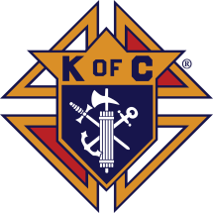



Special Collection for Property and Liability Insurance
BALANCE TO COLLECT: $10,000.00
Every Sunday we will be having a Second Collection
for our Property and Liability Insurance for the year
2018/2019 which is around $19,000.00.
Therefore, we request that you help
us to raise money for this necessary expenditure.
Please write checks to $9,000.00
Assumption/Building Fund. $5,000.00
Thank you for your generosity.
May God Bless You, Fr. Peter $2,000.00

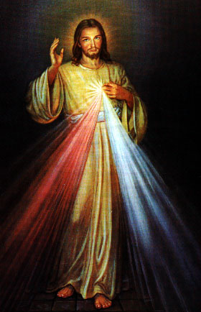
Third Annual Christmas Bazaar
November 20, 21 and 22
Attention: There will be a work day on Saturday, October 10 at 10 a.m. in Gillespie Hall! We need your ideas! It will take all of us participating to make our Bazaar a success!!!

Eggrolls by Agnes, order now.
She will only make 20 dozen.
They are $40 per dozen.
Pick up will be Friday, October 16.
Place order and pay at the office.

Order Tamales by Carmen
at $25.00 per dozen.
Order and pay at the office.
Pick up will be
Saturday, Nov 14.

The profit will equally be divided between three Parishes: Walters, Duncan and Marlow for the purpose of the building fund. We need your time, talent and treasure to make this event successful.

Abuse of Minors Response Hotline 405-720-987 or DHS at 1-800-522-3511.
Telefóno Pastoral para Reportar Abuso de Menores 405-720-9878 o el Departamento de Servicios Humanos 1-800-522-3511.

Religious Education (RE) Families:
Please note the following dates:
Sunday, March 11 | Class
Wed, March 14 | NO CLASS
Sun, Mar 18 | NO CLASS SPRING BREAK
Wed, Mar 21 | NO CLASS SPRING BREAK
Sun, Mar 25 | NO CLASS PALM SUNDAY
Wed, Mar 28 | NO CLASS HOLY WEEK
Sun, Apr 1 | NO CLASS EASTER SUNDAY
Wed, Apr 4 | Class
Wed Apr 4 @ 6:30 pm | Confirmation Mass Practice  In Church
Sun, April 8, 2018 | NO CLASS  Confirmation Mass @ 10am
Wed, Apr 11 | Class
Sat, May 5, 2018 | First Communion Retreat/Reconciliation  @ 1:00-3:00 pm
Sun, May 6, 2018 | First Communion Mass @ 10am

It’s BUNCO time again!
Don’t Miss out on the fun.
All Parish ladies are invited.


MONDAY, MARCH 12 AT 7 P.M.

Assumption Catholic Church,
Gillespie Hall
Only $5 per person for fun & fellowship

Please RSVP

Call or text: 580-475-5754,
580-450-5360 or 580-251-1744

Mark your calendar for Catholic Foundation’s presentation on wills and trusts. This will be held on Monday, October 24 at 7 p.m. at Assumption Catholic Church Gillespie Hall. Come and learn how to take care of those you love.
You can have a Mass said for someone's intentions at their birthday, wedding, baptism, or in memory of your deceased loved ones. Contact he office for days and times that you wish to have the Mass celebrated. What a precious gift!

Duncan Altar Society News

There is an Easter Bake Sale on Saturday and Sunday, March 24-25 after all Masses.

Attention all Ladies: Please make items to sell for the bake sale.

Attention all Parishioners: Please make your purchase of home-made goodies for Easter to support our Altar Society.


Seder Meal
Immaculate Conception
Wednesday, March 28 at 6 p.m.
Please sign up prior to
Sunday, March 25 or call
Bill Havron at 580-512-6867.
There is a list of items
to bring contact
Bette Cooper at 580-641-1350

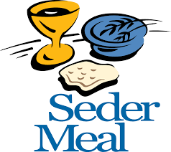

Immaculate Conception Church
Marlow
*********************************
Collections:
Mar 4: General-$961.00

SCHOLARSHIPS!!! - IT IS THAT TIME AGAIN
ASSUMPTION CATHOLIC CHURCH and the Knights of Columbus Council No. 5168 are again accepting applications for the Jesse Wayne Moore Scholarships for the graduating seniors wishing to further their education this year. A few scholarships, from $300 to $1,500 are available. You may obtain application forms from Jim Surjaatmadja or the Assumption Church Office and submit the applications and the necessary documents ON or BEORE Monday, April 23, 2018 to the Church's office or myself. All applications will be judged on Parish activities, community activities and scholastic achievements. A note to all Parish Members: On behalf of the Knights and the graduating Seniors, we would like to thank everyone for the generous contributions that help make the Scholarship Program continue throughout the years. But, we will need your support again for the years to come. For this, again we will ask your continued generous monthly contributions. Please write your checks to Assumption Church Scholarship Fund. Thank you again for your continuing support! Jim Surjaatmadja, Scholarship Chairman, Knights of Columbus 5168.

Saint Patrick Catholic Church
Walters, Oklahoma 73572
********************************
Collections:
Mar 4: Operating $691.00
Building Fund: $508.00

DUNCAN COLLECTIONs FOR
Mar 3-4:
Duncan: $1,757.98
Weekly Electronic Donations: $1,200.00
Building Fund: $1,018.00
Food Bank: $122.00
St. Vincent de Paul: $83.00
Scholarship: $21.00
RYAN: $151.00
Thank you for your generosity!!!

