Sixth Sunday of Ordinary Time
February 11, 2018

Mass Intentions / Peticiones de Misa

Sat | Feb 10 | 4:00p D | (+) Twila Van Leeuwen  LENTEN MISSION  We invite you to attend our  Lenten Mission with  Fr. Jarek Topolewski,  Pastor of Okeene Parish this  Thursday, February 15 at 7 pm,  Friday, February 16 at 7 p.m.  and celebrating all  weekend Masses.  By Carmie and Don Ferland
 |  | 6:00p R | (+) Aldine Maier | Christmas Bazaar  Our Christmas Bazaar  will be held  November 18, 19 and 20.  We hope everyone is making  beautiful items for sale.  There will also be a raffle for  three Visa cards:  $1,000, $500 and $250!  The raffle tickets are for sale now!  They are $5.00 each or five for $20.00! Please buy tickets and  also check them out to sell.  Let’s come together and  work hard to make this a  successful event!
Sun | Feb 11 | 8:00a M | (+) Joy Mathis  By Mark and Fran Gildon
 |  | 10:00a D | (+) Twila Van Leeuwen  By Carmie and Don Ferland
 |  | 12:00p W | (+) Henry Renschen
 |  | 2:00p D | Good Health for Jose Jaume
Mon | Feb 12 | 12:10p D | (+) Twila Van Leeuwen  By Carmie and Don Ferland
Tues | Feb 13 | 12:10p D | Healing for Carolina Trejo  By the Family
Wed | Feb 14 | 12:10p D | For Pat & Steve Neal on their Anniversary
 |  | 7:00p D | Good Health for Francisa Leyva
Thur | Feb 15 | 12:10p D | (+) Aldine Maier  ASH Wednesday Masses  February 14  12:10 p.m.  7:00 p.m.  In Duncan only
Fri | Feb 16 | 12:10p D | Living & Deceased Members  of the Altar Society
Sat | Feb 17 | 4:00p D | (+) Aldine Maier
 |  | 6:00p R | Good Health for Margaret & Andrew Snowden
Sun | Feb 18 | 8:00a D | (+) Joy Mathis  By Mark and Fran Gildon
 |  | 10:00a D | (+) Constantine Sonny Mattioli
 |  | 12:00p W | (+) Paul
 |  | 2:00p D

Special Collection for Property and Liability Insurance
$11,000.00
Every Sunday we will be having a Second Collection
for our Property and Liability Insurance for the year
2018/2019 which is around $19,000.00.
Therefore, we request that you help
us to raise money for this necessary expenditure.
Please write checks to $8,000.00
Assumption/Building Fund. $5,000.00
Thank you for your generosity.
May God Bless You, Fr. Peter $2,000.00

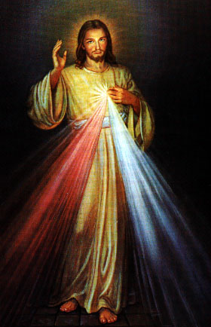
Third Annual Christmas Bazaar
November 20, 21 and 22
Attention: There will be a work day on Saturday, October 10 at 10 a.m. in Gillespie Hall! We need your ideas! It will take all of us participating to make our Bazaar a success!!!

Eggrolls by Agnes, order now.
She will only make 20 dozen.
They are $40 per dozen.
Pick up will be Friday, October 16.
Place order and pay at the office.

Order Tamales by Carmen
at $25.00 per dozen.
Order and pay at the office.
Pick up will be
Saturday, Nov 14.

The profit will equally be divided between three Parishes: Walters, Duncan and Marlow for the purpose of the building fund. We need your time, talent and treasure to make this event successful.

Abuse of Minors Response Hotline 405-720-987 or DHS at 1-800-522-3511.
Telefóno Pastoral para Reportar Abuso de Menores 405-720-9878 o el Departamento de Servicios Humanos 1-800-522-3511.

Mark your calendar for Catholic Foundation’s presentation on wills and trusts. This will be held on Monday, October 24 at 7 p.m. at Assumption Catholic Church Gillespie Hall. Come and learn how to take care of those you love.
You can have a Mass said for someone's intentions at their birthday, wedding, baptism, or in memory of your deceased loved ones. Contact he office for days and times that you wish to have the Mass celebrated. What a precious gift!

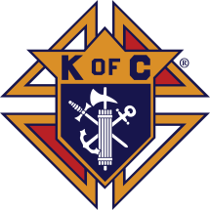

Fish Fry Fridays
Sponsored by
The Marlow/Duncan
Knights of Columbus
Fridays: Feb 16, 23
Mar 2,9,16 & 23,
5:30-7:30 p.m.
At Immaculate Conception Church,
307 N 4th St, Marlow
Carry-outs welcome
580-658-2365
Fish, fries, coleslaw, beans, drink and dessert
$9.00 for adults and children 10 AND UNDER FREE

Stations of the Cross at 6 p.m.

Religious Education (RE) Families:
Please note the following dates:
Sunday, February 11 | Class
Wednesday, February 14 | No Class: Ash Wednesday
Sunday, February 18 | Class
Wednesday, February 21 | Class
Sunday, February 25 | Class
Sun, April 8, 2018 | Confirmation Mass @ 10am
Sat, May 5, 2018 | First Communion Retreat/Reconciliation  @ 1:00-3:00 pm
Sun, May 6, 2018 | First Communion Mass @ 10am

Catholic Charities in Lawton are offering Immigration Consultation for an appointment please call 580-353-1811.

Caridades catolicas ofrecen el servicio de consultas de inmigracion su oficina en Lawton. Por mas informacion llama : 580-353-1811.

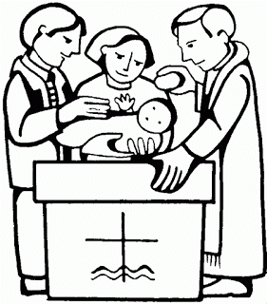
Platicas del Sacramento de Bautizmo
en Español
Marzo 3, Mayo 26, Agosto 18, Noviembre 10, Son a la 7 p.m. en La capilla.
Para mas informacioń
llame a la oficina
580-255-0590 ex 11,
o Carmen Garcia 580-255-6337 Gracias

The envelopes are still in the pews so you can still donate to the Archdiocese Annual Catholic Appeal!

Saint Patrick Catholic Church
Walters, Oklahoma 73572
********************************
Collections:
Feb 4: Operating $
Building: $

Immaculate Conception Church
Marlow
*********************************
Collections:
Feb 4: General-$1,040
Building: $65.00

South Region, ACCW Meeting
“Woman of Faith in Action”
Saturday, February 10th, 2018
St. Patrick Catholic Church
Registration/Hospitality 9:30 am
Guest Speaker: YASMIN BERBER,Catholic Charities
Lawton Regional Office Dir.
Other: Communion Service, Lunch
Silent Auction
(Don’t forget your item) & Door prizes!
RSVP: Barbara Wann 580.875.2278

Oklahoma City, ACCW
Lenten Retreat, Saturday, February 24, 2018
9 am – 2 pm
Holy Family Catholic Church, Lawton, OK 73572

DUNCAN COLLECTIONs FOR
Feb 3-4:
Duncan: $1,449.00
Weekly Electronic Donations: $1,200.00
Building Fund: $299.00
Food Bank: $36.00
St. Vincent de Paul: $35.00
RYAN: $126.00
Thank you for your generosity!!!

