Twentieth Sunday in Ordinary Time
August 20, 2017

Christmas Bazaar 2017

Our Christmas Bazaar will be held
November 17, 18 and 19.

RAFFLE TICKETS:
1 Tkt for $20
6 Tkts for $100


*1st - $3,000
*2nd - $1,000
*3rd ; $500
*4th - $250
*5th - $250
Drawing Sunday, Nov 19 at 5 p.m.
Need not be present to win.
Mass Intentions / Peticiones de Misa

Sat | Aug 19 | 4:00p D | (+) Esteban Perez , Gregorian
 |  | 6:00p R | For the Parishioners
Sun | Aug 20 | 8:00a M |  | Christmas Bazaar  Our Christmas Bazaar  will be held  November 18, 19 and 20.  We hope everyone is making  beautiful items for sale.  There will also be a raffle for  three Visa cards:  $1,000, $500 and $250!  The raffle tickets are for sale now!  They are $5.00 each or five for $20.00! Please buy tickets and  also check them out to sell.  Let’s come together and  work hard to make this a  successful event!
 |  | 10:00a D | ((+) Teresa Zima  by Marilyn McEnroe
 |  | 12:00p W
 |  | 2:00p D | (+) Esteban Perez , Gregorian
Mon | Aug 21 | 12:10p D | (+) Esteban Perez, Gregorian
Tues | Aug 22 | 7:00p D | (+) Esteban Perez , Gregorian
Wed | Aug 23 | 12:10p D | (+) Esteban Perez , Gregorian
Thur | Aug 24 | 12:10p D | (+) Esteban Perez , Gregorian  (+) Alice Barnes by the Family
Fri | Aug 25 | 12:10p D | (+) Esteban Perez , Gregorian
Sat | Aug 26 | 4:00p D | (+) Esteban Perez , Gregorian
 |  | 4:00p R | For the Parishioners
Sun | Aug 27 | 8:00a M
 |  | 10:00a D | (+) Mary Brunin  by Marilyn McEnroe
 |  | 12:00p W
 |  | 2:00p D | (+) Esteban Perez , Gregorian
We would like to thank everyone who has donated items and volunteered their time and talent for the Annual Mexican Garage Sale. The sale made $1,000.00.



Platicas del Sacramento
de Bautizmoen Español
Agosto 26 and Diciembre 2
Son a la 7 p.m. en La capilla
Para mas informacioń
llame a la oficina
580-255-0590 ex 11,
o Carmen Garcia
580-255-6337 Gracias
PLEASE NOTICE: The Mass for Ryan on Saturday, August 26 is at 4 p.m.!

Beginning RCIA Classes –
2017-2018
RCIA (The Rite of Christian Initiation for Adults) is a vibrant informative program for adults who are interested in joining the Catholic Church. If you are interested or know of someone who is interested in learning about our Catholic Faith, RCIA Inquiry one hour sessions will be starting SUNDAY, AUGUST 27, 2017 after the 10AM Mass in Duncan. An open invitation is also extended to current Catholics that want to know and learn more about our faith as well as Catholic Adults interested in becoming Catechist (Teachers) or Sponsors. For additional information on these RCIA Inquiry sessions, please contact Mike or Lucy Radtke at 606-0283 or 656-7582 or email mikelucy@live.com.

Third Annual Christmas Bazaar
November 20, 21 and 22
Attention: There will be a work day on Saturday, October 10 at 10 a.m. in Gillespie Hall! We need your ideas! It will take all of us participating to make our Bazaar a success!!!

Eggrolls by Agnes, order now.
She will only make 20 dozen.
They are $40 per dozen.
Pick up will be Friday, October 16.
Place order and pay at the office.

Order Tamales by Carmen
at $25.00 per dozen.
Order and pay at the office.
Pick up will be
Saturday, Nov 14.

The profit will equally be divided between three Parishes: Walters, Duncan and Marlow for the purpose of the building fund. We need your time, talent and treasure to make this event successful.

Just so you know: Assumption Parish has paid in full property insurance and worker’s comp insurance which amounted to $18,352.00. Thank you for your generosity.

Abuse of Minors Response Hotline 405-720-987 or DHS at 1-800-522-3511.
Telefóno Pastoral para Reportar Abuso de Menores 405-720-9878 o el Departamento de Servicios Humanos 1-800-522-3511.

Mark your calendar for Catholic Foundation’s presentation on wills and trusts. This will be held on Monday, October 24 at 7 p.m. at Assumption Catholic Church Gillespie Hall. Come and learn how to take care of those you love.
You can have a Mass said for someone's intentions at their birthday, wedding, baptism, or in memory of your deceased loved ones. Contact he office for days and times that you wish to have the Mass celebrated. What a precious gift!


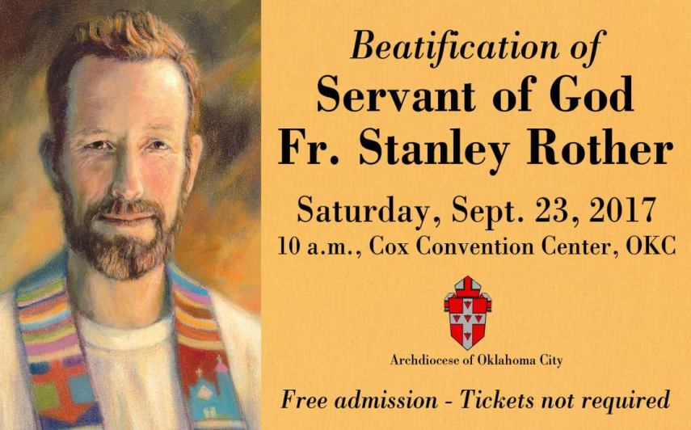

Enrollment:
Welcome back to the 2017-2018 Religious Education classes. Enrollment will take place after each mass starting the weekend of August 19-20. You may enroll during the week at the office. A donation of $30.00 per family will be collected to help with supplies and materials teachers might need in the classroom. Classes will begin on Sunday, September 17, 2017 at 11:00am (after mass is over)- 12:30pm for grades 7-12 and Wednesday, September 20, 2017 from 6:00pm-7:30pm for grades 1-6.

Catechist there will be a meeting on September 30th at 6:30 in the Religious Education (RE) building. Dinner will be provided!

For any questions please contact me at (580) 255-0590 or email at
Maria.martinez02@yahoo.com

Beautification of
Fr. Stanley Rother

Marlow is taking a bus to the Beatification of Fr. Stanley Rother on Saturday, September 23, 2017. Anyone wanting to ride the bus from Duncan, Walters or Marlow needs to sign up no later than Thursday, August 31, 2017. A Donation for the transportation will be taken on the day of travel. The bus will leave Marlow @ 7:00 a.m. on Saturday, September 23.

To sign up, call Kathi Havron 641-1867, or Bill Havron 512-6867. This is a chance of a lifetime! The bus can hold 56 people, and first come, first serve!

We will have the bus all day, so we can eat afterwards. With this bus there is no hassle with parking.

DUNCAN COLLECTIONs FOR
Aug 12-13:
Duncan: $1,359.91
Weekly Electronic Donations: $1,000.00
Second Collection: $254.00
Food Bank: $200.00
St. Vincent de Paul: $20.00\
Charismatics: $250.00
Assumption BVM Mass: $529.00
RYAN: $150.00
Thank you for your generosity!!!

Immaculate Conception Church
Marlow
**********************************
Collections:
Aug 13: Operating: $731.00
Building: $150.00

Rother Heritage Gallery
adds weekend hours

The Heritage Gallery at the Catholic Pastoral Center, 7501 Northwest Expressway, is presenting “The Shepherd Cannot Run: A retrospective on the life of Father Stanley Rother.” The exhibit is open 9 a.m. - 4 p.m. Monday-Friday, and on the following Saturdays from 9 a.m. to Noon: July 29 and Aug. 19. The exhibit is free. Special tours arranged by calling (405) 721-5651, Ext. 141.

