Eighth Sunday of Ordinary Time
February 26, 2017

Mass Intentions / Peticiones de Misa


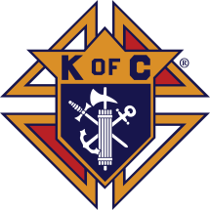

Fish Fry Fridays
Sponsored by The Marlow/Duncan Knights of Columbus

Fridays: March 3, 10, 17, 24, 31
April 7, 5:30-7:30 p.m.
At Immaculate Conception Church,
307 N 4th St
Marlow, OK

Carry-outs welcome
580-658-2365

Fish, fries, coleslaw, beans,
drink and dessert

$9.00 for adults and
children under 8 free

Stations of the Cross at 6:00 p.m.
Sat | Feb 25 | 4:00p D | (+) Bobbi
 |  | 6:00p R | For the Parishioners
Sun | Feb 26 | 8:00a M | (+) Brooke Eoff  by Louise Adams
 |  | 10:00a D | (+) Bobbi
 |  | 12:00p W
 |  | 2:00p D
Mon | Feb 27 | 12:10p D | (+) Bobbi
Tues | Feb 28 | 12:10p D | (+) Bobbi
Wed | Mar 1 | 12:10p D | (+) Bobbi
 |  | 7:00p D | (+) Cecilia and Michael
Thur | Mar 2 | 12:10p D | (+) Bobbi
Fri | Mar 3 | 12:10p D | (+) Bobbi
Sat | Mar 4 | 4:00p D | (+) Bobbi
 |  | 6:00p R | (+) Jo Ann Hebert
Sun | Mar 5 | 8:00 a M
 |  | 10:00a D | (+) Jo Ann Hebert
 |  | 12:00p W | For the Parishioners | Our Second Collection will be for the Food Bank and Christmas Decorations. There are envelopes in the pews. Thank you for your generosity!
 |  | 2:00p D | (+) Humberto Campos by  The Family and Wife

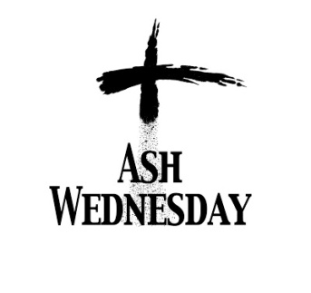

March 1, 2017
Masses at 12:10 p.m. and 7:00 p.m.
Duncan only

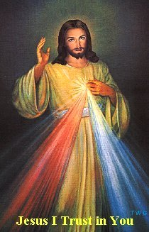

Come and join us every week day for Adoration of the Blessed Sacrament and recitation of The Divine Mercy Chaplet and Rosary at 11:30 a.m. followed by our daily Mass at 12:10 p.m.
Les invitamos todos los días a la adoración del Santísimo a las 11:30 a.m. antes de nuestra misa diaria 12:10 p.m.

DID YOU KNOW:
A Gregorian Mass is for the
faithfully departed.
The Holy Mass is said daily
for thirty days.
Call the office for more information.

Third Annual Christmas Bazaar
November 20, 21 and 22
Attention: There will be a work day on Saturday, October 10 at 10 a.m. in Gillespie Hall! We need your ideas! It will take all of us participating to make our Bazaar a success!!!

Eggrolls by Agnes, order now.
She will only make 20 dozen.
They are $40 per dozen.
Pick up will be Friday, October 16.
Place order and pay at the office.

Order Tamales by Carmen
at $25.00 per dozen.
Order and pay at the office.
Pick up will be
Saturday, Nov 14.

The profit will equally be divided between three Parishes: Walters, Duncan and Marlow for the purpose of the building fund. We need your time, talent and treasure to make this event successful.

Abuse of Minors Response Hotline 405-720-987 or DHS at 1-800-522-3511.
Telefóno Pastoral para Reportar Abuso de Menores 405-720-9878 o el Departamento de Servicios Humanos 1-800-522-3511.

Mark your calendar for Catholic Foundation’s presentation on wills and trusts. This will be held on Monday, October 24 at 7 p.m. at Assumption Catholic Church Gillespie Hall. Come and learn how to take care of those you love.
You can have a Mass said for someone's intentions at their birthday, wedding, baptism, or in memory of your deceased loved ones. Contact he office for days and times that you wish to have the Mass celebrated. What a precious gift!

Duncan Altar Society News
Attention Ladies: There will be an Altar Society Meeting on Thursday, March 2. We will meet after the 12:10 p.m. Mass. You are invited to bring something to share for lunch.
Religious Education News!

Grades 7-12/Confirmation:
Sundays from 11-12:30
March 12 No Class, Spring Break

Grades 1-6:
Wednesdays from 6:00-7:00 p.m.
No Classes:
March 1, Ash Wednesday
March 8, Catechist Meeting
March 15, Spring Break

Save the Dates: 10 a.m. Mass
Confirmation Sunday, April 23
First Communion,
Sunday, May 7

Duncan Toy Shop
Spud Luncheon, $7.00 per person
Tuesday, March 7, 11:00-1:30 p.m.
First United Methodist Church,
2300 Country Club Rd
Contact Cecilia Dowhower for tickets
No

World Day of Prayer
Friday, March 3
First Christian Church, Gathering Hall,
912 W Walnut Ave
Sponsored by The Church Women United
Mary Frances Cox, featured speaker
Begins at 9:30 a.m.

2017 Lenten Retreat
The Council of Catholic Women, provinces of Oklahoma City and Tulsa, is providing a Lenten retreat on Saturday, March 4, at the Catholic Pastoral Center. Speaker Maria Morena Johnson is a Catholic author and speaker. In her first book, “My Badass Book of Saints: Courageous Women Who Showed Me How to Live,” she shares family stories of immigration, illness and hope. She speaks nationally on topics such as Internet safety for families, the saints and women’s topics. The retreat is 9 a.m. to 3:45 p.m. with Mass at 4 p.m. Cost is $30, including continental breakfast and lunch. Register online at www.okcaccw.com and click on the retreat link. Contact Mary Ann Schmitt at (405) 650-9674.

Encounter with God’s Call
A seminary discernment retreat at Conception Seminary College April 1-3 for high school juniors through college-age men curious about seminary. Contact (660) 944-2886, vocations@conception.edu or go online to www.ewgc.org.

Catholic young adults of OKC
Open to all young adults (ages 18-39, married or single) in the archdiocese. Visit our Facebook page (Catholic Young Adults of OKC) for events and information or e-mail info@catholicyoungadultsokc.com.

In the Father’s Footsteps
Catholic Men’s Conference
Saturday, April 1, 2017,
9 a.m. – 4 p.m.
Norman, OK
Embassy Suites Convention Center
Catholicmen.net

DUNCAN COLLECTIONs FOR
February 11-12:
Duncan: $1,739.76
Weekly Electronic Donations: $1,000.00
Second Collection: $272.65
Food Bank: $66.00
St. Vincent de Paul: $8.00
Ryan: $137.25
Thank you for your generosity!!!

Saint Patrick Catholic Church
THIRD AND OHIO POST OFFICE BOX 151
Walters, Oklahoma 73572
********************************
Collections:
Feb 12: Operating: $380.00

