30th Sunday in Ordinary Time
October 23, 2016

Mass Intentions / Peticiones de Misa

ATTENTION:
There will only be ONE MASS
On Tuesday, Nov 1 at 7 p.m.
for All Saints Day
at Assumption.
Let’s come together and
celebrate All Saints Day!

Sat | Oct 22 | 4:00p D | (+) Paul Jandaczek and  Prayers for the Family  By The Lowe Family
 |  | 6:00p R | For the Parishioners
Sun | Oct 23 | 8:00a M | (+) Benjamin Ryan Gildon
 |  | 10:00a D
 |  | 12:00p W
 |  | 2:00p D
Mon | Oct 24 | 12:10p D | (+) Alice J. Barnes  By The Trostle Family  ATTENTION PLEASE:  You can have a Mass offered for someone's intentions on their birthday, wedding, baptism, or in memory of your deceased loved ones. Contact the office for days and times that you wish  to have the Mass celebrated.  What a wonderful spiritual gift!  A Gregorian Mass is for the faithfully departed.  The Holy Mass is said daily for thirty days.
Tues | Oct 25 | 12:10p D | (+) Paul Jandaczek  and Prayers for the Family  By The Lowe Family
Wed | Oct 26 | 12:10p D | (+) Paul Jandaczek  By Diana McIntyre
Thur | Oct 27 | 12:10p D
Fri | Oct 28 | 12:10p D
Sat | Oct 29 | 4:00p D
 |  | 6:00p R
Sun | Oct 30 | 8:00a M | (+)Benjamin Ryan Gildon
 |  | 10:00a D
 |  | 12:00p W
 |  | 2:00p D | For the Parishioners

Catholic Foundation Presentation on Wills and Trusts!
Mark your calendar for Catholic Foundation’s presentation on wills and trusts.
This will be held this Monday, October 24 at 7 p.m.
at Assumption Catholic Church Gillespie Hall.
Come and learn how to take care of those you love.

Special Collection for Property and Liability Insurance

$17,000.00

Every Sunday we will be having a Second Collection
for our Property and Liability Insurance
which is $8,000.00. We have not done that before
because our regular donations and collections
covered this expense. However, due to the recent $9,000.00
economic turn we have lost around $60,000.00 of our
annual income. Therefore, we request that you help $7,000.00
us to raise money for this necessary expenditure.
Please write checks to Assumption/Building Fund.
Thank you for your generosity. $3,000.00
May God Bless You, Fr. Peter

Third Annual Christmas Bazaar
November 20, 21 and 22
Attention: There will be a work day on Saturday, October 10 at 10 a.m. in Gillespie Hall! We need your ideas! It will take all of us participating to make our Bazaar a success!!!

Eggrolls by Agnes, order now.
She will only make 20 dozen.
They are $40 per dozen.
Pick up will be Friday, October 16.
Place order and pay at the office.

Order Tamales by Carmen
at $25.00 per dozen.
Order and pay at the office.
Pick up will be
Saturday, Nov 14.

The profit will equally be divided between three Parishes: Walters, Duncan and Marlow for the purpose of the building fund. We need your time, talent and treasure to make this event successful.

Mark your calendar for Catholic Foundation’s presentation on wills and trusts. This will be held on Monday, October 24 at 7 p.m. at Assumption Catholic Church Gillespie Hall. Come and learn how to take care of those you love.
You can have a Mass said for someone's intentions at their birthday, wedding, baptism, or in memory of your deceased loved ones. Contact he office for days and times that you wish to have the Mass celebrated. What a precious gift!

Abuse of Minors Response Hotline 405-720-987 or DHS at 1-800-522-3511.
Telefóno Pastoral para Reportar Abuso de Menores 405-720-9878 o el Departamento de Servicios Humanos 1-800-522-3511.


Religious Education News!
Grades 7-12/Confirmation:
Sundays from 11-12:30

Grades 1-6:
Wednesdays from 6:00-7:00 p.m.

No Classes:
Sunday, Oct 23
Sunday, Nov 20
Wednesday, Nov 30
Christmas Bazaar
Our Christmas Bazaar
will be held
November 18, 19 and 20.

We hope everyone is making
beautiful items for sale.

There will also be a raffle for
three Visa cards:
$1,000, $500 and $250!
The raffle tickets are for sale now!
They are $5.00 each or five for $20.00! Please buy tickets and
also check them out to sell.

Let’s come together and
work hard to make this a
successful event!



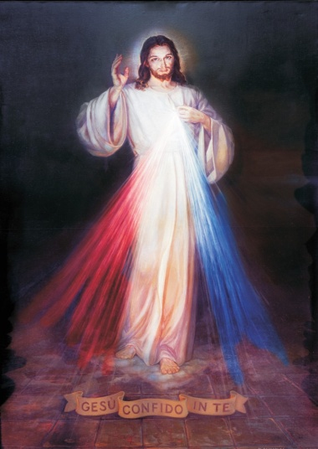

Our Chapel is called the Divine Mercy and St. John Paul II Chapel. We have a first class relic of St. John Paul II. We celebrate Adoration of the Blessed Sacrament during the week before the 12:10 p.m. Mass at 11:30. We also say the Divine Mercy Chaplet and Rosary. Everyone is welcome and encouraged to attend.



Did you Know: You can always donate via automatic withdrawal directly to our church's account. It is easy, simple and at the end of the fiscal year you will receive a tax letter acknowledging your donations. For more information stop by the office after each Mass.
Thank you for your support.

Catholic young adults of OKC
Open to all young adults (ages 18-39, married or single) in the archdiocese. Visit our Facebook page (Catholic Young Adults of OKC) for events and information or e-mail info@catholicyoungadultsokc.com.

DUNCAN COLLECTIONs FOR
October 22-23:
Duncan: $2,304.21
Weekly Electronic Donations: $1,200.00
Building Fund: 379.89
Food Bank: $74.00
St. Vincent de Paul: $67.00
Ryan: $68.25
Thank you for your generosity!!!

Saint Patrick Catholic Church
THIRD AND OHIO POST OFFICE BOX 151
Walters, Oklahoma 73572
********************************
Collections:
October 23: Operating: $445.00

