Nineteenth Sunday in Ordinary Time August 10, 2014

The Assumption of the
Blessed Virgin Mary,
Friday, August 15,
is a
Holy Day of Obligation

There will be
one Mass
in Duncan at 7 p.m.
Reception will follow.
Collection will be taken for the benefit of our Food Bank.

Mass Intentions / Peticiones de Misa

Sat | Aug 9 | 4:00p D |  Int of Trudy DeRoberts
 |  | 6:00p R | Int of Fr. John Peter Swaiminathas
Sun | Aug 10 | 8:00a M | (+)Joe Lockovich by Marilyn Smith and Kay Johnson
 |  | 10:00a D | (+)Helen James by  Cecilia Bogle
 |  | 12:00p W | Healing for W. Stanley Moore by Marguerite Moore
 |  | 2:00p D | Int of The Hoelscher Family
Mon | Aug 11 | 12:10p D | Int of Howard Doerr by the  Wolfgang-Deeg Family
Tues | Aug 12 | 12:10p D | Healing for W. Stanley Moore by Marguerite Moore
Wed | Aug 13 | 12:10p D | Int of Gregory,John,Aga, Taeyilla & Tyler
Thur | Aug 14 | 12:10p D | (+)Don Trostle and Jake Seratte  Vacation Bible School (VBS)  August 11-14, 5:30-8:30 p.m.  Monday-Thursday  PK-6th Grade  Register Now!  Children's Mass,  Sunday, August 17 at 10 a.m.
Fri | Aug 15 | 7:00p D | Healing for W. Stanley Moore by Marguerite Moore
Sat | Aug 16 | 4:00p D | Int of Karen,Mike Kuchem
 |  | 6:00p R | Int of Bryan,Kathy, Sophie & Gladys
Sun | Aug 17 | 8:00a M | (+) Alfred Pittman by  Cheryl Lockovich
 |  | 10:00a D | Int of Robert Neal on His B-D
 |  | 12:00p W | Int of Barnes-Sutter-Bohan Households
 |  | 2:00p D | Int of Juanita, Scott & Alfred
Second Annual Christmas Bazaar
Coming in December, 2014!!!!!!
Everyone can participate and make items for our Christmas Bazaar. Proceeds will be distributed: 50% to the Building Fund, 25% to St. Vincent de Paul and 25% to our Food Bank. More details to follow! Everyone can contribute!

Main Sanctuary Project Renovations Goal $27,000
As you can see the renovations of our church
through your generosity are almost completed. $25,000
However, the main sanctuary which includes the main
wall with the crucifix is still in need of the major update. $20,000
Therefore, as of this weekend we will take up second
collections for this project. The cost of the insulation, $15,000
lighting and facing of the wall is $27,000. Currently
we have $19,000 in our building fund designated
for this project. Hence, we still need $8,000. $5,000
Thank you for your generosity and support. May God Bless you! $3,000

You can have a Mass said for someone's intentions at their birthday, wedding, baptism, or in memory of your deceased loved ones. Contact he office for days and times that you wish to have the Mass celebrated. What a precious gift!

Abuse of Minors Pastoral Response Hotline 405-720-987 or DHS at 1-800-522-3511. Línea Telefónica Pastoral para Reportar Abuso de Menores 405-720-9878 o el Departamento de Servicios Humanos al 1-800-522-3511.

!!!Religious Education News!!!
The Religious Education 2014-2015 Program will begin on Wednesday, September 3 (6-7:15 pm) for grades 1-8 and September 7 (5-6:15 pm) for grades 9-12/Confirmation. By our Baptism, we are called to share the Good News. Please consider your gifts and talents. If you would like to be a part of helping our children become excited about God please contact Maria Martinez 580-467-0184 or Pat Neal 580-255-0590 or talk with Fr. Peter. There are many ways to help!

El programa de Educación Religioso para 2014-2015 comenzara septiembre 3 para grados 1-8 y septiembre 7 para grados 9-12/Confirmación. Por nuestro bautismo, somos Ilamados a dar la Buena Nueva. Considera los regalos y talentos que Dios te ha regalado y si quieres formar parte en ayudar que a los niños conozcan de Dios por favor de comunicarse con Maria Martinez 580-467-0184, Pat Neal 580-255-0590, o hable con Padre Pedro. Puedes ayudar de muchas formas.
+++++++++++
R.E. Teacher's Meeting, Sunday, August 17 after the 10 a.m. Mass. All R.E. teachers and assistants are invited. We will show the new Safe Environment DVD.

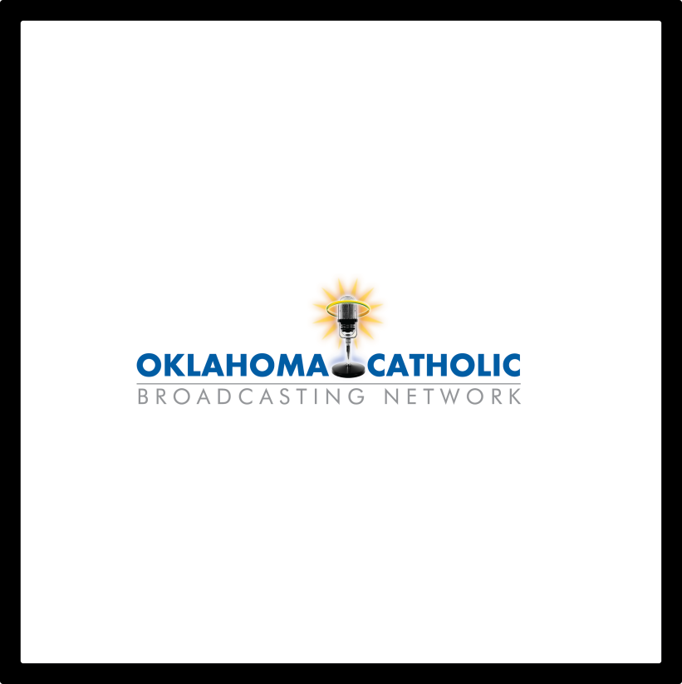
“Bringing quality Catholic programming to the Oklahoma air waves.”
Find us on your radio dial at:
97.3 FM Oklahoma City
88.3 FM Lawton Tambien en español:
Se puede escuchar los programas en español desde las 13:00 hasta anochecer de lunes a viernes - 890 AM Oklahoma City and 1570 AM Tulsa.
If you cannot pick up any of the area stations, you can listen online through our website at www.okcatholicbroadcasting.com and click on “Listen Online”. We hope to bring Catholic Radio to your area as well as other small communities in Oklahoma. CONTACT US at 405-255-7348. You may also email Jeff Finnell, President, OCB at jeff@okcatholicbroadcasting.com or Marlene Stapp, Secretary, OCB at mstapp4@gmail.com.

Grupo Guadalupano Garage Sale
3 Anual Garage Sale
Aceptamos donaciones de Muebles, ropa, juguetes, trastes, etc... Durante el garaje habrá tacos de carnitas con tortillas hechas en casa y nachos y sodas.
Si vas a donar comunícate con:
Noé tel 475-4892, Maria Jones 467-8794,
Carmen Garcia 255-6337 para recoger tu donación.

Guadalupe 3rd Annual Garage Sale,
Date to be Announced Later
Assumption's Auditorium
We're accepting donations: furniture, clothing, toys, dishes, etc... During the garage sale we will be selling pork tacos with homemade tortillas, nachos and sodas. To donate contact:
Noé Sanchez 475-4892, Maria Jones 467-8794
or Carmen Garcia at 255-6337.

Platicas del Sacramento de Bautizmo
en Español
del año 2014 Serań en:
Septiembre 6, Noviembre 8
Son a la 7 p.m. en La capilla.
Para mas informacioń
llame a la oficina
580-255-0590 ex 11,
o Carmen Garcia 580-255-6337 Gracias

DUNCAN COLLECTIONs FOR august 2-3:
Duncan: $4,062.08
Weekly Electronic Donations: $1,200.00
Building: Sanctuary Project: $474.03
Hispanic Garage Sale for Sanctuary Project: $1,000.00
Food Bank: $140.00
St. Vincent de Paul: $255.00
Ryan: $150.00
Thank you for your generosity!!!

Please remember you can support
our Parish with electronic donations!
Sign up today!!!
In order for us to process your electronic donation, we will need from you: voided check and a signed authorization form. Please come to the office after one of our weekend Masses or during the week. For those of you that would like to increase your electronic donations please let us know.

Saint Patrick Catholic Church
THIRD AND OHIO POST OFFICE BOX 151
Walters, Oklahoma 73572
**************************************
Collections:
July 27: Operating--$206.00/Bldg--$125.00
Aug 3: Operating--$578.27/Building--$463.00
Thank you for your generosity!!!

Please remember your Parish in your will.

