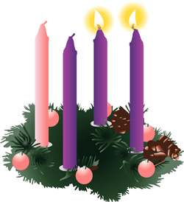
Second Sunday of Advent
December 8, 2013

Mass Intentions / Peticiones de Misa

Christmas Mass Schedule:
Christmas Eve, Tuesday, December 24,
4 pm Marlow
4 pm Walters
6 pm Duncan
12 Midnight Duncan
Christmas Day, Wednesday, December 25
10 am Duncan
10 am Ryan

Sat | Dec 7 | 4:00p D | (+)Alejandro Rodriguez  by Carolyn Trostle
 |  | 6:00p R | For the Parishioners
Sun | Dec 8 | 8:00a M | (+)Gloria Roys
 |  | 10:00a D | (+)Pedro Martinez by Alicia
 |  | 12:00p W | (+)Virginia Hufnagel by Jim
 |  | 2:00p D | Int of Michael & Karen Kuchem | We would like to invite everyone to attend a Good-bye Party for Fr. Joseph on Sunday, June 30 at 5 p.m. in Gillespie Hall. The Knights of Columbus are providing hamburgers and hot dogs. We will have a money tree for Fr. Joseph.  We would like to invite everyone to attend a Good-bye Party for Fr. Joseph on Sunday, June 30 at 5 p.m. in Gillespie Hall. The Knights of Columbus are providing hamburgers and hot dogs. We will have a money tree for Fr. Joseph.
Mon | Dec 9 | 12:10p D | Int of Hosek Family & Friends
Tues | Dec 10 | 12:10p D | Int of Frank Cyrkiewicz Jr
Wed | Dec 11 | 12:10p D | Many Blessings for Anna Fitts on Her Birthday | Come decorate the Church for  Our Lady of Guadalupe on  Tuesday, Dec 10 at 5 p.m. and  Christmas Masses on Sunday, Dec 22  at 3 p.m. We need your help!
 |  | Midnight D | Guadalupe Mass | FIRST FRIDAY ADORATION  ADORACIÓN _{DEL} 1er VIERNES  August 2  from 12:30 pm (after mass) - 9 pm  Benediction will be from 8:45 - 9 pm  de 12:30 pm (después de misa) - 9 pm  La Bendición será de 8:45 - 9 pm  FIRST FRIDAY ADORATION  April 5  from 12:30 pm (after mass) - 9 pm  Benediction will be from 8:45 - 9 pm  FIRST FRIDAY ADORATION  April 5  from 12:30 pm (after mass) - 9 pm  Benediction will be from 8:45 - 9 pm
Thur | Dec 12 | 12:10p D | Int of Howard Doerr by the  Wolfgang-Deeg Family
Fri | Dec 13 | 12:10p D | (+)Virginia Hufnagel by Jim | FIRST FRIDAY ADORATION  ADORACIÓN _{DEL} 1er VIERNES  August 2  from 12:30 pm (after mass) - 9 pm  Benediction will be from 8:45 - 9 pm  de 12:30 pm (después de misa) - 9 pm  La Bendición será de 8:45 - 9 pm
Sat | Dec 14 | 4:00p D | (+)Don Trostle/Jake Seratte
 |  | 6:00p R | For the Parishioners  You're Invited to:  St. Patrick's Church in Walters for a Note Burning Party and Mass of thanksgiving for paying off their New Parish Hall debt on  Sunday December 15 at 5 p.m.  Please note there will be no 12 noon Mass.  A potluck supper will be shared after the Mass. Please bring a dish to share.
Sun | Dec 15 | 8:00a M | (+)Fr. Joseph's Father
 |  | 10:00a D | (+)Gloria Roys
 |  | 2:00p D | Int of Ann & Shirley Jean
 |  | 5:00p W | Int of Sarah & Mary
The office will be closed in observance of Christmas and New Years Mon, Dec 23 through Wed, Jan 1!

Our lady of Guadalupe celebration

Everyone is invited to the annual celebration
of the Virgin of Guadalupe.

Tuesday, December 11
10:00pm ---------------------- Procession
11:00pm ---------------------- Matachines
(Traditional dancers)
Two Talks
Mañanitas
(Songs to Mary)
12 midnight ----------------- Mass
After Mass ------------------- Light Breakfast

Wednesday, December 12
6:00pm ------------------------ Rosary
7:00pm ------------------------ Apparition
8:00pm ------------------------ Dinner
After Dinner ------------------ Matachines
Folkloric Dances

la fiesta de
La VIRGEN DE GUADALUPE

Todos están invitados a lacelebración anual
de la Virgen de Guadalupe.

El martes, 11 de diciembre
10:00pm ---------------------- La Procesión
11:00pm ---------------------- Los Matachines
Dos Temas
Las Mañanitas
12 medianoche -------------- La Misa
Después de Misa ------------ El Desayuno

El miércoles, 12 de diciembre
6:00pm ---------------------- El Rosario
7:00pm ---------------------- La Aparición
8:00pm ---------------------- La Cena
Después de Cena ----------- Matachines
Bailables

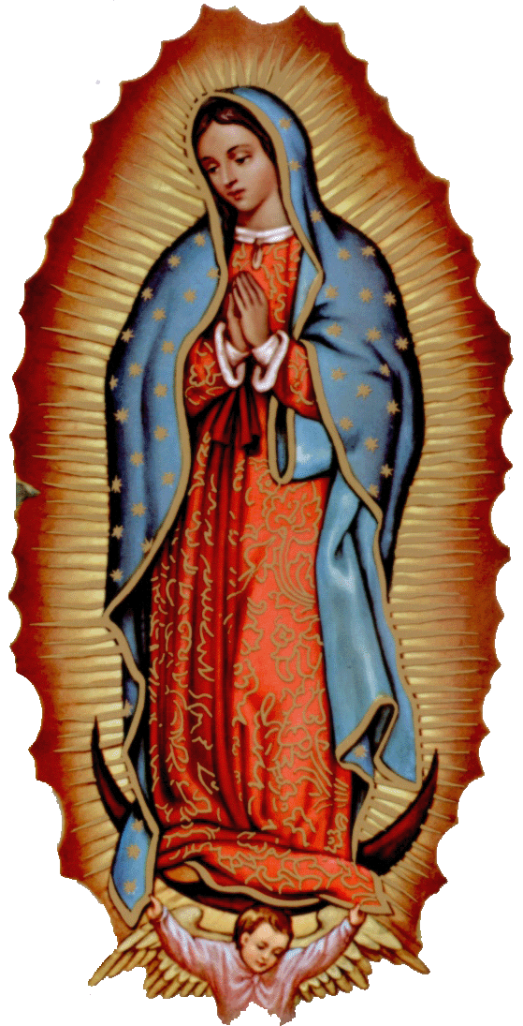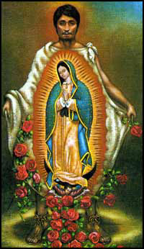

405-720-9878 Abuse of Minors Pastoral Response Hotline 405-720-9878 You may also contact Oklahoma Department of Human Services at 1-800-522-3511.
405-720-9878 Línea Telefónica Pastoral para Reportar Abuso de Menores 405-720-9878También puede comunicarse con el Departamento de Servicios Humanos al 1-800-522-3511.


!!!Religious Education News!!!
Grades 1-8 meet Wednesdays 6:00-7:15 pm
Grades 9-12 meet Sundays 5:00-6:15 p.m.
Parents: for their safety
your children must be signed in and out!
Please be on time to pick up your children!!!

Attention Parents:
Christmas Break - No Classes on:
Sundays, Dec 22, 29 and Jan 5
Wednesdays, Dec 25 and Jan 1

Duncan Altar Society News:

After Craft Bazaar Sale on
Sunday, December 8
before and after
10 am and 2pm Masses.
Come and buy your Christmas gifts early at good prices!

Attention: If you're interested in serving on Assumption's Parish Council please
send us your bio and the
reason you want to serve via e-mail.
Don't forget the Holiday Food Fund!
There are envelopes in the pews.

Choir Practice Saturday at 2 p.m. and
Sunday Choir Review at 8:45 a.m.
We invite those interested in singing in the Choir to join us for practice in the Choir Loft!

Duncan Area Literacy Council is sponsoring English as a Second Language Classes at our Parish. The classes are taking place twice a week on Tuesday and Thursday mornings from 10-11 a.m. at the R.E. Bldg. For more information call 580-736-1170.
El Consejo de Alfabetizacion de Duncan ofrecera clases de ingles en R. E Bldg. Las clases seran los martes y jueves por la manana de 10-11 a.m.

Want to Meet other Youth?

Join Assumption's YOUTH GROUP!!!
Youth grades 7-12 are invited to come join us for faith,
games and socializing!
Meetings are every SUNDAY in the R.E. Auditorium Building
from 6:20-8:00 p.m.
For more information contact Youth Coordinator
Armando at 405/779-0285.
Unirse a grupo de jóvenes supuesto!!!
Los jóvenes los grados 7-12 están invitados a
unirse a nosotros por la fe, juegos y socializar. Las reuniones son todos los domingos a partir de septiembre 29 en el R. E. Auditorio del Edificio de 6:20 -8:00 p.m. para obtener más información, póngase en contacto con Coordinador de la Juventud
Armando en 405/779-0285.


Interested in Becoming Catholic
and joining our Church?
The "Rite of Christian Initiation of Adults" (RCIA) is a spiritual instructional and ritual process for adults. Those adults wishing to become a member of the Catholic Church through the Sacraments of Baptism, Confirmation and Eucharist are welcome and encouraged to inquire about the RCIA Session starting soon. Please contact Mike Radtke (606-0283) for information on participating in this Rite.

Please remember you can support
your Church with automatic donations!
Sign up today to automatically donate
your Sunday offering especially during vacation times!
In order for us to process your automatic donation, we will need from you: voided check and a signed authorization form. Please come to the office after one of our weekend Masses or during the week.

You are invited to a concert by Cristiano Rizzotto, who plays the organ for Duncan Masses. The Concert will be at the First Presbyterian Church, 1302 SW "A", Lawton on Sunday, Dec 22 at 4 p.m.
DUNCAN COLLECTIONs FOR
December 1:
Duncan: $3,340.03
Building: $100.00
Ryan: $59.00
Holiday Food Fund: $579.25
Weekly Direct Deposit Donations: $1,100.00

Saint Patrick Catholic Church
THIRD AND OHIO POST OFFICE BOX 151
Walters, Oklahoma 73572
**************************************
Collections:
Dec 1: Operating: $861.00 and Bldg: $159.25

Please remember your Parish in your will.

