Twentieth Sunday in Ordinary Time
August 19, 2018



Everyone is invited to a Christmas Bazaar
organizational meeting on
TUESDAY, AUGUST 21
at 7 p.m. in Gillespie Hall

Mass Intentions / Peticiones de Misa

Sat | Aug 18 | 4:00p D
 |  | 6:00p R
Sun | Aug 19 | 8:00a M | (+) Delores Havron  By Bill & Kathi Havron
 |  | 10:00a D | (+) Amanda Chavez
 |  | 12:00a W
 |  | 2:00p D | NO SPANISH MASS
Mon | Aug 20 | 12:10p D | NO MASS
Tues | Aug 21 | 12:10p D
Wed | Aug 22 | 12:10p D | Int of Henry Renchen
Thur | Aug 23 | 12:10p D
Fri | Aug 24 | 12:10p D | (+) Alice Barnes
Sat | Aug 25 | 4:00p D | Alexander Verde Birthday wishes  By Marisel
 |  | 6:00p R
Sun | Aug 26 | 8:00a M | (+) Tiffany Ford
 |  | 10:00a D | (+) Forys Family
 |  | 12:00p W
 |  | 2:00p D | NO SPANISH MASS



It’s BUNCO time again!
Don’t Miss out on the fun.
All Parish ladies are invited.
MONDAY, August 27 AT 6:30 P.M.
Immaculate Conception Parish Hall,
Marlow
Only $5 per person
fun & fellowship

Must RSVP by Friday, August 23!!!
Call or text: 580-641-1350

ATTENTION: There will be NO Daily 12:10pm Mass on Monday, August 20!

Immaculate Conception Church
Marlow
*********************************
Collections:
Aug 12: General $926.00 /Building $670.00

Saint Patrick Catholic Church
Walters, Oklahoma 73572
********************************
Collections:
August 12: Operating: $

Beginning RCIA Classes – 2018-2019
RCIA (The Rite of Christian Initiation for Adults) is a vibrant informative program for adults who are interested in joining the Catholic Church. If you are interested or know of someone who is interested in learning about our Catholic Faith, RCIA Inquiry one hour sessions will be starting SUNDAY, September 9, 2018 after the 10AM Mass in Duncan. An open invitation is also extended to current Catholics that want to know and learn more about our faith as well as Catholic Adults interested in becoming Catechist (Teachers) or Sponsors. For additional information on these RCIA Inquiry sessions, please contact Mike or Lucy Radtke at 606-0283 or 656-7582 or email mikelucy@live.com

DUNCAN COLLECTIONs FOR
August 12:
Duncan: $1,554.00
Weekly Electronic Donations: $1,200.00
Building Fund: $464.00
Food Bank: $97.00
St. Vincent de Paul: $5.00
San Jose: $216.00
Scholarship: $10.00
Thank you for your generosity!!!

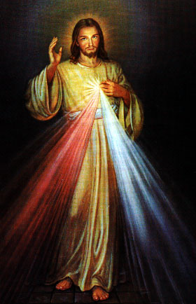
Third Annual Christmas Bazaar
November 20, 21 and 22
Attention: There will be a work day on Saturday, October 10 at 10 a.m. in Gillespie Hall! We need your ideas! It will take all of us participating to make our Bazaar a success!!!

Eggrolls by Agnes, order now.
She will only make 20 dozen.
They are $40 per dozen.
Pick up will be Friday, October 16.
Place order and pay at the office.

Order Tamales by Carmen
at $25.00 per dozen.
Order and pay at the office.
Pick up will be
Saturday, Nov 14.

The profit will equally be divided between three Parishes: Walters, Duncan and Marlow for the purpose of the building fund. We need your time, talent and treasure to make this event successful.

