Fifteenth Sunday in Ordinary Time
July 15, 2018

Mass Intentions / Peticiones de Misa

Sat | July 14 | 4:00p D | (+) Don Trostle & Jake Seratte
 |  | 6:00p R | For the Parishioners
Sun | July 15 | 8:00a M | (+) Joe Delk  by Phil & Louise Adams
 |  | 10:00a D | (+) Helen James by The Family
 |  | 12:00a W
 |  | 2:00p D
Mon | July 16 | 12:10p D
Tues | July 17 | 12:10p D | For Karen Cottom’s Birthday
Wed | July 18 | 12:10p D | NO MASS
Thur | July 19 | 12:10p D
Fri | July 20 | 12:10p D | For Joy Wade’s Birthday
Sat | July 21 | 4:00p D
 |  | 6:00p R
Sun | July 22 | 8:00a M | (+) Joe Delk by Susan Evans
 |  | 10:00a D | For Victoria on her Birthday
 |  | 12:00p W
 |  | 2:00p D | (+) Humberto Campos

Did you know?
You can have a Mass said in memory of a loved one. What a wonderful gift! A Gregorian Mass is a set of thirty Masses said for the repose of the soul of a deceased love one. Stop by the office to reserve your date(s).


There will be NO 12:10 p.m. Daily Mass on Wednesday, July 18!

Special Collection for Property and Liability Insurance
BALANCE TO COLLECT: $4,000.00
Every Sunday we will be having a Second Collection
for our Property and Liability Insurance for the year
2018/2019 which is around $19,000.00.
Therefore, we request that you help $15,000.00
us to raise money for this necessary expenditure.
Please write checks to
Assumption/Building Fund. $5,000.00
Thank you for your generosity.
May God Bless You, Fr. Peter $2,000.00

Abuse of Minors Response Hotline 405-720-987 or DHS at 1-800-522-3511.
Telefóno Pastoral para Reportar Abuso de Menores 405-720-9878 o el Departamento de Servicios Humanos 1-800-522-3511.

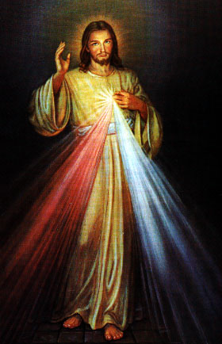
Third Annual Christmas Bazaar
November 20, 21 and 22
Attention: There will be a work day on Saturday, October 10 at 10 a.m. in Gillespie Hall! We need your ideas! It will take all of us participating to make our Bazaar a success!!!

Eggrolls by Agnes, order now.
She will only make 20 dozen.
They are $40 per dozen.
Pick up will be Friday, October 16.
Place order and pay at the office.

Order Tamales by Carmen
at $25.00 per dozen.
Order and pay at the office.
Pick up will be
Saturday, Nov 14.

The profit will equally be divided between three Parishes: Walters, Duncan and Marlow for the purpose of the building fund. We need your time, talent and treasure to make this event successful.

