Fourteenth Sunday in Ordinary time
July 8, 2018

Mass Intentions / Peticiones de Misa

Sat | July 7 | 4:00p D | (+) Clarence Rezac  By Marilyn McEnroe
 |  | 6:00p R
Sun | July 8 | 8:00a M | (+) Joe Lockovich
 |  | 10:00a D
 |  | 12:00a W
 |  | 2:00p D
Mon | July 9 | 12:10p D
Tues | July 10 | 12:10p D
Wed | July 11 | 12:10p D
Thur | July 12 | 12:10p D
Fri | July 13 | 12:10p D
Sat | July 14 | 4:00p D | (+) Don Trostle  And (+) Jake Seratte
 |  | 6:00p R
Sun | July 15 | 8:00a M | (+) Joe Delk  By Phil & Louise Adams
 |  | 10:00a D
 |  | 12:00p W
 |  | 2:00p D

Did you know?
You can have a Mass said in memory of a loved one. What a wonderful gift! A Gregorian Mass is a set of thirty Masses said for the repose of the soul of a deceased love one. Stop by the office to reserve your date(s).


Immaculate Conception Church
Marlow
*********************************
Collections:
June 24: General-$688.00
Building: $150.00

We have daily adoration
and pray the
Chaplet of Divine Mercy
and the Rosary
Monday through
Friday at
11:30 a.m.
before the 12:10 Mass.
Everyone is invited
to participate and
spend time with Jesus
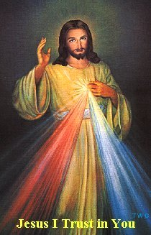

Saint Patrick Catholic Church
Walters, Oklahoma 73572
********************************
Collections:
June 24: Operating $242.00
Building: $170.00

DUNCAN COLLECTIONs FOR
June 23-24:
Duncan: $1,197.00
Weekly Electronic Donations: $1,200.00
Building Fund: $572.00
Guadalupe Garage Sale: $1,000.00
Food Bank: $20.00
St. Vincent de Paul: $10.00
Thank you for your generosity!!!

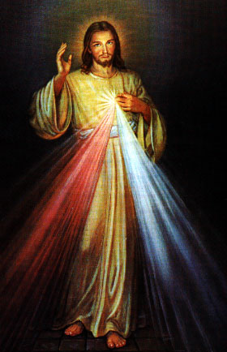
Did you Know: You can always donate via automatic withdrawal directly to our church's account. It is easy, simple and at the end of the fiscal year you will receive a tax letter acknowledging your donations. For more information stop by the office after each Mass.
Thank you for your support.

Third Annual Christmas Bazaar
November 20, 21 and 22
Attention: There will be a work day on Saturday, October 10 at 10 a.m. in Gillespie Hall! We need your ideas! It will take all of us participating to make our Bazaar a success!!!

Eggrolls by Agnes, order now.
She will only make 20 dozen.
They are $40 per dozen.
Pick up will be Friday, October 16.
Place order and pay at the office.

Order Tamales by Carmen
at $25.00 per dozen.
Order and pay at the office.
Pick up will be
Saturday, Nov 14.

The profit will equally be divided between three Parishes: Walters, Duncan and Marlow for the purpose of the building fund. We need your time, talent and treasure to make this event successful.

Mark your calendar for Catholic Foundation’s presentation on wills and trusts. This will be held on Monday, October 24 at 7 p.m. at Assumption Catholic Church Gillespie Hall. Come and learn how to take care of those you love.
You can have a Mass said for someone's intentions at their birthday, wedding, baptism, or in memory of your deceased loved ones. Contact he office for days and times that you wish to have the Mass celebrated. What a precious gift!

