Twenty-sixth Sunday in Ordinary Time September 28, 2014

Mass Intentions / Peticiones de Misa

Sat | Sep 27 | 4:00p D | (+)George E. Coughlin  Second Annual Christmas Bazaar  December 5, 6 & 7, 2014 in R.E. Bldg.  Friday, December 5, 4-8 p.m.  Saturday, December 6, 10 a.m.-7 p.m.  St. Nicholas Party for Children, 6-8 p.m.,  in Gillespie Hall  Sunday, December 7, 11 a.m. - 5 p.m.  Order Tamales by Carmen  at $25.00 per dozen.  Order and pay at the office  if you're interested!  Buy Raffle tickets now:  1. Beautiful Christmas centerpiece. Tickets are $1.00 each or six tickets for $5.00.  2. $500 Southwest Airlines Gift Card. Tickets are $5.00 each.  Will be raffled off on Sunday, December 7 at Bazaar!  Proceeds will be distributed: 50% to the Building Fund, 25% to St. Vincent de Paul and 25% to our Food Bank. Everyone can contribute!
 |  | 6:00p R | For Parishioners
Sun | Sep 28 | 8:00a M | Infant Child of Isaac Martin by Joe Murphey
 |  | 10:00a D | (+)George E. Coughlin
 |  | 12:00p W | (+)Julia Ann Smith Sealy by Kathleen Flanagan
 |  | 2:00p D | For Parishioners
Mon | Sep 29 | 12:10p D | (+)George E. Coughlin
Tues | Sep 30 | 12:10p D | 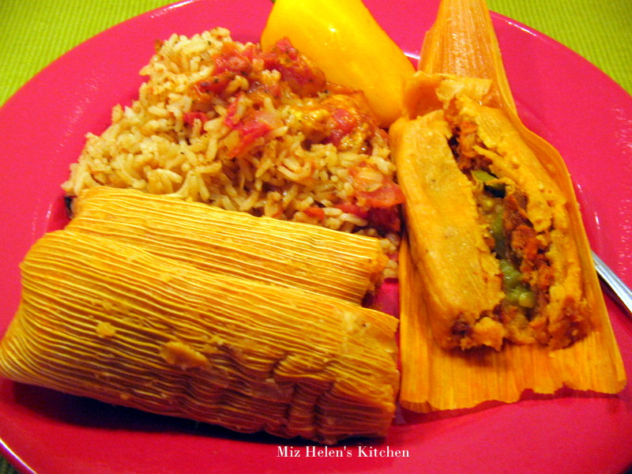(+)George E. Coughlin
Wed | Oct 1 | 12:10p D | (+)George E. Coughlin
Thur | Oct 2 | 12:10p D | (+)George E. Coughlin
Fri | Oct 3 | 12:10p D | (+)George E. Coughlin
Sat | Oct 4 | 4:00p D | For the Living & Deceased Members of the Altar Society
 |  | 6:00p R | (+)George E. Coughlin
Sun | Oct 5 | 8:00a M | (+)Alfred Pittman by KofC
 |  | 10:00a D | (+)George E. Coughlin
 |  | 12:00p W | For the Living and Deceased Members of the KofC
 |  | 2:00p D | (+)Jose Ocha by  Lee & Maria Jones

Upcoming Events:

Sun., Oct 12, Celebration canceled.
Sun., Oct 19: Children's Mass at 10 a.m.
Tues, Oct 21: Healing Mass at 7 p.m.
Sun., Oct 26: National Council of Catholic Women (NCCW) Sunday. Let's honor women in the church!
Sat., Nov 1: 12:10 p.m. All Saints Feast Day Mass
Sun, Nov 16: Children's Mass at 10 a.m.
Sun, Nov 23: Praise & Worship Mass at 6 p.m., Assumption
Mon., Dec 8: Immaculate Conception Feast Day Mass, 7 p.m. in Marlow, one Mass only

FIRST FRIDAY ADORATION
ADORACIÓN _{DEL} 1er VIERNES
October 3

from 12:30 pm (after mass) - 3 p.m.
6 p.m. - 9 p.m.
Benediction will be from 9 pm
de 12:30 pm (después de misa) - 3 pm
6 p.m. - 9 p.m.
La Bendición será de 9 pm

On the weekend of September 27-28, Rev. Basil Keenan, OSB, will be taking a second collection for the Catholic Scholarship Fund benefitting Catholic students who attend St. Gregory's University. Your generosity will be appreciated.
You can have a Mass said for someone's intentions at their birthday, wedding, baptism, or in memory of your deceased loved ones. Contact he office for days and times that you wish to have the Mass celebrated. What a precious gift!

Abuse of Minors Pastoral Response Hotline 405-720-987 or DHS at 1-800-522-3511. Línea Telefónica Pastoral para Reportar Abuso de Menores 405-720-9878 o el Departamento de Servicios Humanos al 1-800-522-3511.

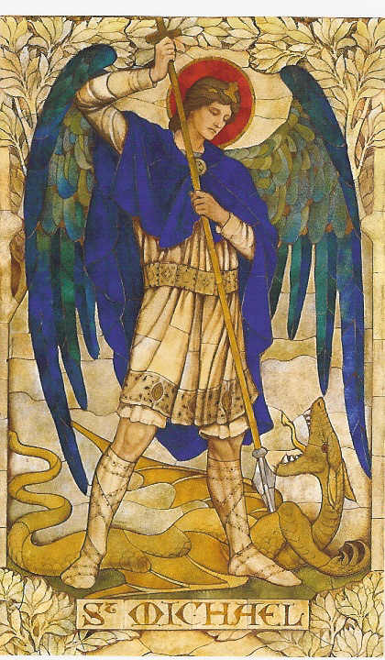
Prayer to Saint Michael
the Archangel
St. Michael the Archangel, defend us in battle. Be our defense against the wickedness and snares of the Devil. May God rebuke him, we humbly pray, and do thou, O Prince of the heavenly hosts, by the power of God, thrust into hell Satan, and all the evil spirits, who prowl about the world seeking the ruin of souls. Amen
!!!Religious Education News!!!
1st-7th Grades, Wednesdays
6:00-7:15 p.m.
8th-12th Grades, Sundays
11:15 a.m. - 12:30 p.m.

Dates to Remember:

Sun, Oct 5: Teacher's Meeting, lunch provided
Sun, Oct 22: Fall Break No R.E. Class
Sun, Oct 26: R. E. Class, Saint Fair
Wed, Oct 29: R.E. Class, Halloween Carnival

R.C.I.A. (Rite of Christian Initiation of Adults)
is a spiritual instructional and ritual process for adults. Those adults wishing to become members of the Catholic Church through the Sacraments of Baptism, Confirmation and the Eucharist are welcome and encouraged to inquire about the RCIA session starting soon. Please contact Mike Radtke (606-0283) for information on participating in this Rite.

11 de Octubre tendnemos la kermas anual para sacar fondos para la fiesta de la Virgen de Guadalupe necesitamos puestos de comida o juegos, necasitamos tu colaboracion comunicate con Noe Sanchez o Carmen Garcia Gracias
_________________________________________
Ultreya el 4° dom despues de misa te esperamos

Attention: There is an Altar Society Meeting on Thursday, October 2 after the 12:10 Mass. Bring a dish to share and a friend!

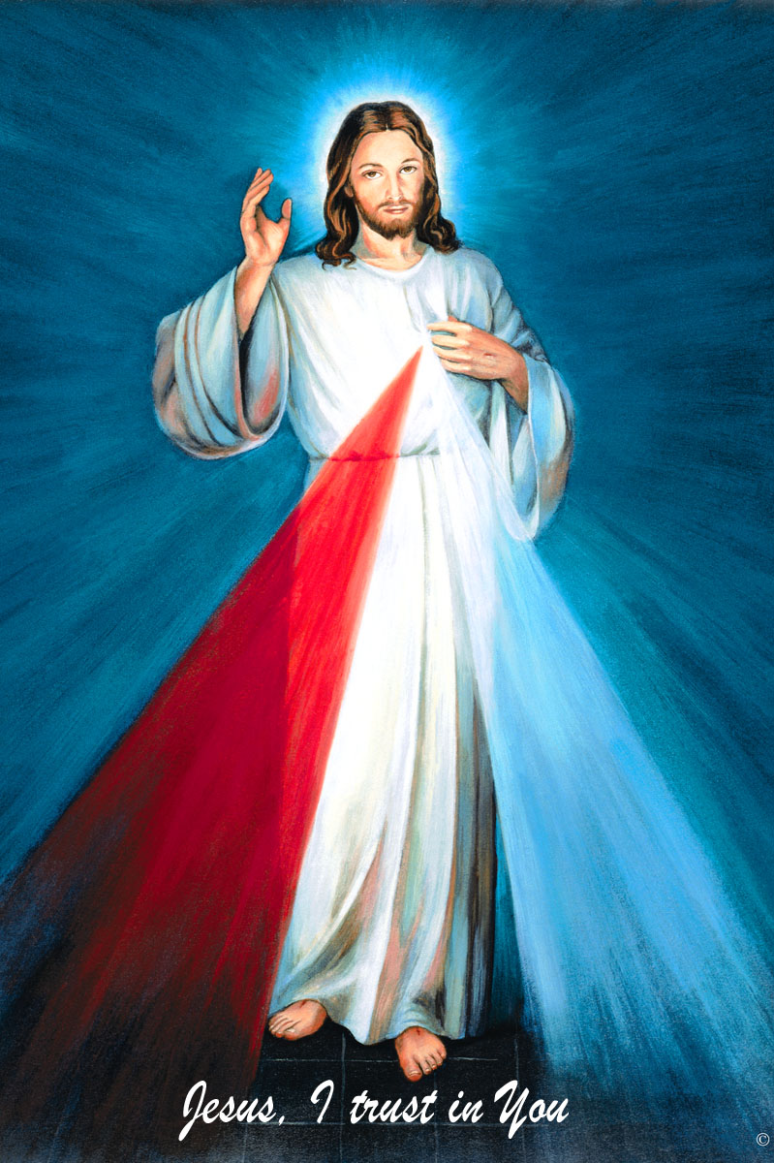
Women of Faith/Women of Action Conference
Saturday, October 18 at St. Eugene's Catholic Church, Oklahoma City
Mary, Woman of Grace
Registration at 8 a.m.
To register go online: okcaccw.com
Adults $40, Youth $25 and Religious no charge
The Divine Mercy Chaplet
and Rosary are prayed
every day at 11:45 in our
Divine Mercy and
Blessed John Paul II
Chapel before our
12:10 Noon Mass.
Please come and spend time with Jesus!

you'll be glad you did!

Rehearsals on Saturdays from 2:00-3:30 p.m. at Assumption of the Blessed Virgin Mary Church and Warm-ups on Sunday from 8:45-9:30 a.m.

Second Collections in October:
Oct 18-19: Breast Cancer Foundation of America October is Breast Cancer Awareness Month

Oct 25-26: Waters of Life, Builds water wells in a third world country
Please remember you can support
our Parish with electronic donations!
Sign up today!!!
In order for us to process your electronic donation, we will need from you: voided check and a signed authorization form. Please come to the office after one of our weekend Masses or during the week. For those of you that would like to increase your electronic donations please let us know.

Please remember your Parish in your will.

