Twenty-Third Sunday in Ordinary Time September 7, 2014

Mass Intentions / Peticiones de Misa

Upcoming Events:
Sun., Sep 21: Children's Mass at 10 a.m.
Sun., Oct 12, Celebration canceled see note below.
Sun., Oct 19: Children's Mass at 10 a.m.
Tues, Oct 21: Healing Mass at 7 p.m.
Sun., Oct 26: National Council of Catholic Women (NCCW) Sunday. Let's honor women in the church!
Sat., Nov 1: 12:10 p.m. All Saints Feast Day Mass
Sun, Nov 16: Children's Mass at 10 a.m.
Sun, Nov 23: Praise & Worship Mass at 6 p.m., Assumption
Mon., Dec 8: Immaculate Conception Feast Day Mass, 7 p.m. in Marlow, one Mass only

Sat | Sep 6 | 4:00p D | (+)Paula Estrada  by Alicia Martinez
 |  | 6:00p R | For Parishioners
Sun | Sep 7 | 8:00a M | (+)Alfred Pittman by the KofC
 |  | 10:00a D | (+)Anna Oei by Jim & Agnes
 |  | 12:00p W | (+)Julia Ann Smith Sealy by  Kathleen Flanagan
 |  | 2:00p D | (+)Jose Vasquez by Rita Robles
Mon | Sep 8 | 12:10p D | NO MASS-CLERGY DAYS OKC
Tues | Sep 9 | 12:10p D | NO MASS-CLERGY DAYS OKC
Wed | Sep 10 | 12:10p D | Int of Frank,Daniel & Lance
Thur | Sep 11 | 12:10p D | Int of Howard Doerr by The Wolfgang-Deeg Family
Fri | Sep 12 | 12:10p D | (+)George E. Coughlin
Sat | Sep 13 | 4:00p D | (+)George E. Coughlin
 |  | 6:00p R | For Parishioners  Due to an unforeseen conflict in The Archbishop's schedule Most Reverend Paul Coakley will not be able to preside over our Sunday, October 12 Saint John Paul II Celebration Mass. Therefore our Celebration and Parish Appreciation Dinner will be postponed to a later date. All Masses will be as usual: 8 a.m. Marlow, 10 a.m. Duncan, 12 noon at Walters and Spanish Mass in Duncan at 2 p.m.
Sun | Sep 14 | 8:00a M | (+)Marvin Tucker by  Gail Boehm
 |  | 10:00a D | Birthday Blessings & Good Health for Ann Boice
 |  | 12:00p W | (+)Don Trostle and Jake Seratte
 |  | 2:00p D | (+)George E. Coughlin

Second Annual Christmas Bazaar
Coming December 5, 6 & 7, 2014!
We are looking for everyone to participate and share your time, talent and treasurer in making this Christmas Bazaar a great success. Proceeds will be distributed: 50% to the Building Fund, 25% to St. Vincent de Paul and 25% to our Food Bank. Everyone can contribute!

PLEASE NOTICE: There will be no Daily 12:10 p.m. Masses on Monday and Tuesday, September 8-9 because the Priests will be attending Clergy Days in Oklahoma City.

Altar Society News: We will collect dues of $10 this weekend and next! All ladies of the Parish are members of the Altar Society!

Please notice: There will be a Parish Council meeting on Tuesday, September 16 at 7 p.m. The Finance Council will meet at 6 p.m.

Main Sanctuary Project Renovations Goal $27,000
As you can see the renovations of our church
through your generosity are almost completed. $25,000
However, the main sanctuary which includes the main
wall with the crucifix is still in need of the major update. $20,000
Therefore, as of this weekend we will take up second
collections for this project. The cost of the insulation, $15,000
lighting and facing of the wall is $27,000. Currently
we have $23,500 in our building fund designated
for this project. Hence, we still need $3,500. $5,000
Thank you for your generosity and support. May God Bless you! $3,000

You can have a Mass said for someone's intentions at their birthday, wedding, baptism, or in memory of your deceased loved ones. Contact he office for days and times that you wish to have the Mass celebrated. What a precious gift!

Abuse of Minors Pastoral Response Hotline 405-720-987 or DHS at 1-800-522-3511. Línea Telefónica Pastoral para Reportar Abuso de Menores 405-720-9878 o el Departamento de Servicios Humanos al 1-800-522-3511.

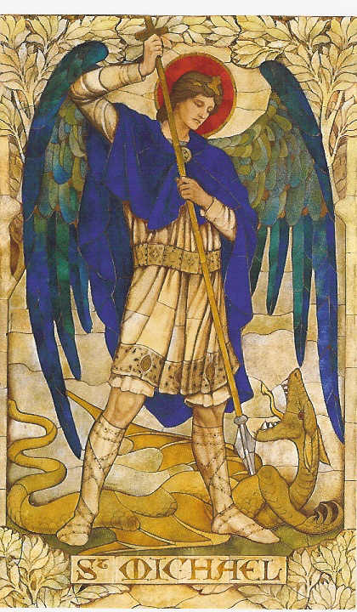
Prayer to Saint Michael
the Archangel
St. Michael the Archangel, defend us in battle. Be our defense against the wickedness and snares of the Devil. May God rebuke him, we humbly pray, and do thou, O Prince of the heavenly hosts, by the power of God, thrust into hell Satan, and all the evil spirits, who prowl about the world seeking the ruin of souls. Amen
!!!Religious Education News!!!
Please enroll this weekend after all Masses or during the week in the office.

Dates to Remember:
Sun, Sep 7 first day of class (Grades 8-12)
Class Time: 11:15 a.m. - 12:30 p.m.
Wed, Sep 17 Parent Meeting, 6:15 p.m.
Sun, Oct 5 Teacher's Meeting, lunch provided

ADORATION of
the Blessed Sacrament
Thursdays & Fridays
September 11, 12 and
September 18, 19
from 7:00-8:00 p.m.
each evening

Since the public Black Mass in Oklahoma City has not been canceled we're inviting you to join us for a prayerful act of reparation in the public square:

Rosary Rally of Reparation of the Civic Center

When: Sunday, Sep 21 at 5:00-7:00 p.m.
Where: Civic Center, 201 N. Walker Ave, Oklahoma City, OK (Couch Drive & N Walker Avenue.
Your prayers will console Our Lord and the Blessed Mother. Bring your rosary. Bring your friends. Share this alert.

R.C.I.A. (Rite of Christian Initiation of Adults)
is a spiritual instructional and ritual process for adults. Those adults wishing to become members of the Catholic Church through the Sacraments of Baptism, Confirmation and the Eucharist are welcome and encouraged to inquire about the RCIA session starting soon. Please contact Mike Radtke (606-0283) for information on participating in this Rite.
Second Collections in October:

Oct 18-19: Breast Cancer Foundation of America
October is Breast Cancer Awareness Month

Oct 25-26: Waters of Life, Builds water wells in a third world country
DUNCAN COLLECTIONs FOR august 30-31:
Duncan: $1,581.76
Weekly Electronic Donations: $1,225.00
Building: Sanctuary Project: $430.00
Ryan: $101.00
Thank you for your generosity!!!

Saint Patrick Catholic Church
THIRD AND OHIO POST OFFICE BOX 151
Walters, Oklahoma 73572
**************************************
Collections:
August 24: Operating--$353.70/Building--$145.00
August 31: Operating--$233.40/Building--$125.00

Please remember you can support
our Parish with electronic donations!
Sign up today!!!
In order for us to process your electronic donation, we will need from you: voided check and a signed authorization form. Please come to the office after one of our weekend Masses or during the week. For those of you that would like to increase your electronic donations please let us know.

Please remember your Parish in your will.

