Twentieth-Second Sunday in Ordinary Time August 31, 2014

Mass Intentions / Peticiones de Misa

Upcoming Events:
Sun., Sep 21: Children's Mass at 10 a.m.
Sun., Oct 12, at 5 p.m. Archbishop Coakley will celebrate Mass in Duncan commemorating the election of Saint John Paul II as Pope. After the Mass we will have a Parish Appreciation Dinner for all Parishioners of Assumption, Immaculate Conception, St. Patrick and St. Jose. It is free of charge; however, you must contact the office by October 1st to confirm your attendance. Note that on this day there will be only one Mass in Duncan.
Sun., Oct 19: Children's Mass at 10 a.m.
Tues, Oct 21: Healing Mass at 7 p.m.
Sun., Oct 26: National Council of Catholic Women (NCCW) Sunday. Let's honor women in the church!
Sat., Nov 1: 12:10 p.m. All Saints Feast Day Mass
Sun, Nov 16: Children's Mass at 10 a.m.
Sun, Nov 23: Praise & Worship Mass at 6 p.m., Assumption
Mon., Dec 8: Immaculate Conception Feast Day Mass, 7 p.m. in Marlow, one Mass only

Sat | Aug 30 | 4:00p D | (+)Herman Hatch by  The Bennie Wilson Family
 |  | 6:00p R | For Parishioners
Sun | Aug 31 | 8:00a M | Tony Boxell for Healing
 |  | 10:00a D | (+)Anna Oei by Jim & Agnes
 |  | 12:00p W | Int of Elvire,Sharon,Wesley & Genevieve
 |  | 2:00p D
Mon | Sep 1 | 12:10p D | NO MASS
Tues | Sep 2 | 12:10p D | For the Living & Deceased Members of the Knights of Columbus
Wed | Sep 3 | 12:10p D | (+)Anna Oei by Jim & Agnes
Thur | Sep 4 | 12:10p D | For the Living & Deceased Members of the Altar Society
Fri | Sep 5 | 12:10p D | For Ann Emerson's Healing
Sat | Sep 6 | 4:00p D | (+)Paula Estrada  by Alicia Martinez
 |  | 6:00p R | For Parishioners
Sun | Sep 7 | 8:00a M | (+)Alfred Pittman by the KofC
 |  | 10:00a D | (+)Anna Oei by Jim & Agnes
 |  | 12:00p W
 |  | 2:00p D | (+)Jose Vasquez by Rita Robles

Second Annual Christmas Bazaar
Coming December 5, 6 & 7, 2014!
We are looking for everyone to participate and share your time, talent and treasurer in making this Christmas Bazaar a great success. Proceeds will be distributed: 50% to the Building Fund, 25% to St. Vincent de Paul and 25% to our Food Bank. Everyone can contribute!

We invite those who are interested in making this event a great success for a primary meeting on Saturday, September 6 at 10 a.m.

FIRST FRIDAY DORATION
ADORACIÓN _{DEL} 1er VIERNES
September 5
from 12:30 pm (after mass) - 4:00 pm and
7:00 - 8:45 p.m. Benediction at 8:45 p.m.

de 12:30 pm (después de misa) - 4:00 pm
7:00 - 8:45 p.m. La Bendición será de 8:45 pm

Main Sanctuary Project Renovations Goal $27,000
As you can see the renovations of our church
through your generosity are almost completed. $25,000
However, the main sanctuary which includes the main
wall with the crucifix is still in need of the major update. $20,000
Therefore, as of this weekend we will take up second
collections for this project. The cost of the insulation, $15,000
lighting and facing of the wall is $27,000. Currently
we have $22,500 in our building fund designated
for this project. Hence, we still need $4,500. $5,000
Thank you for your generosity and support. May God Bless you! $3,000

You can have a Mass said for someone's intentions at their birthday, wedding, baptism, or in memory of your deceased loved ones. Contact he office for days and times that you wish to have the Mass celebrated. What a precious gift!

Abuse of Minors Pastoral Response Hotline 405-720-987 or DHS at 1-800-522-3511. Línea Telefónica Pastoral para Reportar Abuso de Menores 405-720-9878 o el Departamento de Servicios Humanos al 1-800-522-3511.

Prayer to Saint Michael
the Archangel
St. Michael the Archangel, defend us in battle. Be our defense against the wickedness and snares of the Devil. May God rebuke him, we humbly pray, and do thou, O Prince of the heavenly hosts, by the power of God, thrust into hell Satan, and all the evil spirits, who prowl about the world seeking the ruin of souls. Amen
!!!Religious Education News!!!
Please enroll this weekend after all Masses or during the week in the office.

Dates to Remember:
Wed, Sep 3 first day of Class (Grades 1-7)
Class Time: 6:00-7:15 p.m.
Sun, Sep 7 first day of class (Grades 8-12)
Class Time: 11:15 a.m. - 12:30 p.m.
Wed, Sep 17 Parent Meeting
Sun, Oct 5 Teacher's Meeting, lunch provided
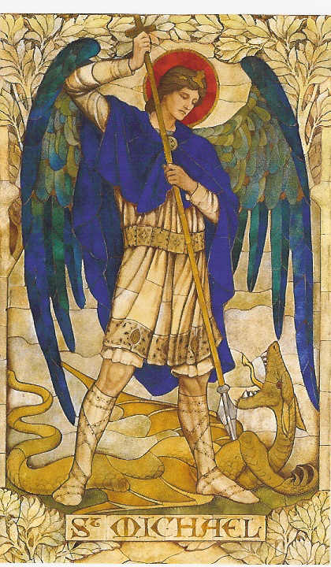

Notice: The office will be closed on Monday, September 1 and there will be no daily 12:10 p.m. Mass in observance of Labor Day!
Altar Society News:
Meeting, Thursday, September 4 after 12:10 Mass. Bring a dish to share and a friend!
All Ladies are invited!

Platicas del Sacramento de Bautizmo
en Español
del año 2014 Serań en:
Septiembre 6, Noviembre 8
Son a la 7 p.m. en La capilla.
Para mas informacioń
llame a la oficina
580-255-0590 ex 11,
o Carmen Garcia 580-255-6337 Gracias

R.C.I.A. (Rite of Christian Initiation of Adults)
is a spiritual instructional and ritual process for adults. Those adults wishing to become members of the Catholic Church through the Sacraments of Baptism, Confirmation and the Eucharist are welcome and encouraged to inquire about the RCIA session starting soon. Please contact Mike Radtke (606-0283) for information on participating in this Rite.

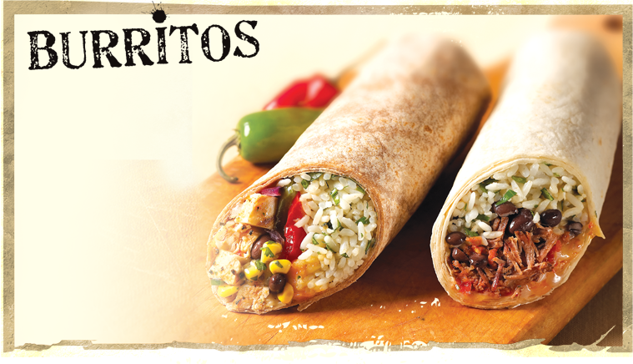
There will be
homemade
burritos and
nachos
for sale after
10:00 a.m. and 2:00 p.m.
Masses Sunday,
August 31st
in Gillespie Hall!
PLEASE NOTICE: There will be no Daily 12:10 p.m. Masses on Monday and Tuesday, September 8-9 because the Priests will be attending Clergy Days in Oklahoma City.
DUNCAN COLLECTIONs FOR august 23-24:
Duncan: $2,266.02
Weekly Electronic Donations: $1,225.00
Building: Sanctuary Project: $570.83
Food Bank: $145.00
Ryan: $192.00
Thank you for your generosity!!!

Please remember you can support
our Parish with electronic donations!
Sign up today!!!
In order for us to process your electronic donation, we will need from you: voided check and a signed authorization form. Please come to the office after one of our weekend Masses or during the week. For those of you that would like to increase your electronic donations please let us know.

Please remember your Parish in your will.

