Twentieth Sunday in Ordinary Time August 17, 2014

Mass Intentions / Peticiones de Misa

Sat | Aug 16 | 4:00p D | Int of Karen & Mike Kuchem  Upcoming Events:  Sun., Oct 12, at 5 p.m. Archbishop Coakley will celebrate Mass in Duncan commemorating the election of Saint John Paul II as Pope. After the Mass we will have a Parish Appreciation Dinner for all Parishioners of Assumption, Immaculate Conception, St. Patrick and St. Jose. It is free of charge; however, you must contact the office by October 1st to confirm your attendance. Note that on this day there will be only one Mass in Duncan.  Sun., Oct 26: National Council of Catholic Women (NCCW) Sunday. Let's honor women in the church!  Sat., Nov 1: 12:10 p.m. All Saints Feast Day Mass  Mon., Dec 8: Immaculate Conception Feast Day Mass, 7 p.m. in Marlow, one Mass only
 |  | 6:00p R | Int of Bryan,Kathy, Sophie & Gladys
Sun | Aug 17 | 8:00a M | (+) Alfred Pittman by  Cheryl Lockovich
 |  | 10:00a D | Int of Robert Neal on His B-D
 |  | 12:00p W | Int of Barnes-Sutter-Bohan Households
 |  | 2:00p D | Int of Juanita, Scott & Alfred
Mon | Aug 18 | 12:10p D | Int of Jennifer, Susan, Bonita & Ben
Tues | Aug 19 | 12:10p D | Int of Francisca, Daniel, Ben & Souls in Purgatory
Wed | Aug 20 | 12:10p D | Healing for W. Stanley Moore by Marguerite Moore
Thur | Aug 21 | 12:10p D | Int of Elvira, Sharon, Wesley and Genevieve
Fri | Aug 22 | 12:10p D | Int of the DeFrancesco Family
Sat | Aug 23 | 4:00p D | (+)Michael R. Martson  by Joe Murphey
 |  | 6:00p R | (+)Florence Folks,  Theresa Blanchard's Mother
Sun | Aug 24 | 8:00a M | Healing for W. Stanley Moore by Marguerite Moore
 |  | 10:00a D | (+)Anna Oei by Jim & Agnes  Second Annual Christmas Bazaar  Coming December 5, 6 & 7, 2014!  We are looking for everyone to participate and share your time, talent and treasurer in making this Christmas Bazaar a great success. Proceeds will be distributed: 50% to the Building Fund, 25% to St. Vincent de Paul and 25% to our Food Bank. Everyone can contribute!  We invite those who are interested in making this event a great success for a primary meeting on Saturday, September 6 at 10 a.m.
 |  | 12:00p W | For Good Health and God's Blessings for Richard
 |  | 2:00p D | (+)Orlando Camacho
R.C.I.A. (Rite of Christian Initiation of Adults)
is a spiritual instructional and ritual process for adults. Those adults wishing to become members of the Catholic Church through the Sacraments of Baptism, Confirmation and the Eucharist are welcome and encouraged to inquire about the RCIA session starting soon. Please contact Mike Radtke (606-0283) for information on participating in this Rite.

Main Sanctuary Project Renovations Goal $27,000
As you can see the renovations of our church
through your generosity are almost completed. $25,000
However, the main sanctuary which includes the main
wall with the crucifix is still in need of the major update. $20,000
Therefore, as of this weekend we will take up second
collections for this project. The cost of the insulation, $15,000
lighting and facing of the wall is $27,000. Currently
we have $21,000 in our building fund designated
for this project. Hence, we still need $6,000. $5,000
Thank you for your generosity and support. May God Bless you! $3,000

You can have a Mass said for someone's intentions at their birthday, wedding, baptism, or in memory of your deceased loved ones. Contact he office for days and times that you wish to have the Mass celebrated. What a precious gift!

Abuse of Minors Pastoral Response Hotline 405-720-987 or DHS at 1-800-522-3511. Línea Telefónica Pastoral para Reportar Abuso de Menores 405-720-9878 o el Departamento de Servicios Humanos al 1-800-522-3511.

!!!Religious Education News!!!
The Religious Education 2014-2015 Program will begin on Wednesday, September 3 (6-7:15 pm) for grades 1-8 and September 7 (5-6:15 pm) for grades 9-12/Confirmation. By our Baptism, we are called to share the Good News. Please consider your gifts and talents. If you would like to be a part of helping our children become excited about God please contact Maria Martinez 580-467-0184 or Pat Neal 580-255-0590 or talk with Fr. Peter. There are many ways to help!

El programa de Educación Religioso para 2014-2015 comenzara septiembre 3 para grados 1-8 y septiembre 7 para grados 9-12/Confirmación. Por nuestro bautismo, somos Ilamados a dar la Buena Nueva. Considera los regalos y talentos que Dios te ha regalado y si quieres formar parte en ayudar que a los niños conozcan de Dios por favor de comunicarse con Maria Martinez 580-467-0184, Pat Neal 580-255-0590, o hable con Padre Pedro. Puedes ayudar de muchas formas.

Grupo Guadalupano Garage Sale
3 Anual Garage Sale
23 de Agosto
Aceptamos donaciones de Muebles, ropa, juguetes, trastes, etc... Durante el garaje habrá tacos de carnitas con tortillas hechas en casa y nachos y sodas.
Si vas a donar comunícate con:
Noé tel 475-4892, Maria Jones 467-8794,
Carmen Garcia 255-6337 para recoger tu donación.

Guadalupe 3rd Annual Garage Sale,
Saturday, August 23
9 a.m. - 5 p.m.
Assumption's Auditorium
We're accepting donations: furniture, clothing, toys, dishes, etc... During the garage sale we will be selling pork tacos with homemade tortillas, nachos and sodas. To donate contact:
Noé Sanchez 475-4892, Maria Jones 467-8794
or Carmen Garcia at 255-6337.

Platicas del Sacramento de Bautizmo
en Español
del año 2014 Serań en:
Septiembre 6, Noviembre 8
Son a la 7 p.m. en La capilla.
Para mas informacioń
llame a la oficina
580-255-0590 ex 11,
o Carmen Garcia 580-255-6337 Gracias

Prayer to Saint Michael
the Archangel
St. Michael the Archangel, defend us in battle. Be our defense against the wickedness and snares of the Devil. May God rebuke him, we humbly pray, and do thou, O Prince of the heavenly hosts, by the power of God, thrust into hell Satan, and all the evil spirits, who prowl about the world seeking the ruin of souls. Amen
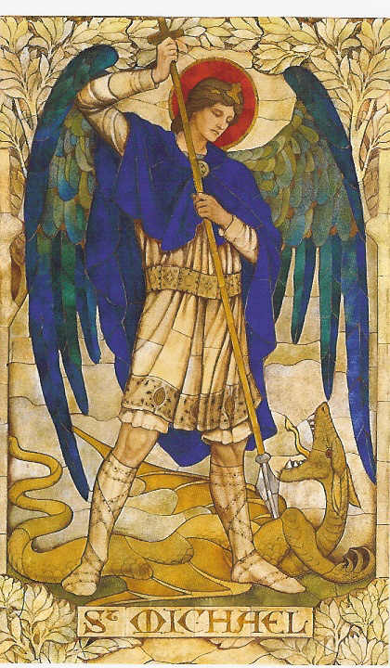

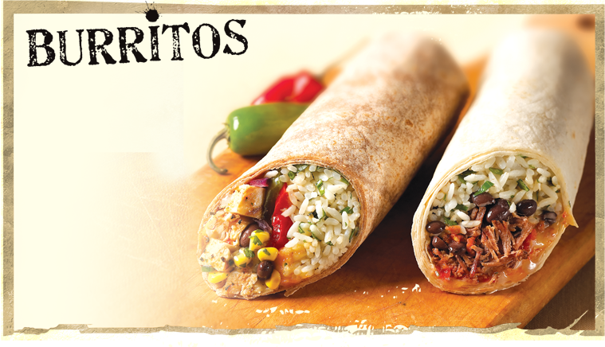
There will be
homemade
burritos and
nachos

for sale after
10:00 a.m. and 2:00 p.m.
Masses Sunday,
August 31st
in Gillespie Hall!
DUNCAN COLLECTIONs FOR august 9-10:
Duncan: $2,722.47
Weekly Electronic Donations: $1,225.00
Building: Sanctuary Project: $2,190.30
Scholarship Fund: $15.00
Food Bank: $20.00
St. Vincent de Paul: $50.00
Ryan: $193.00
Thank you for your generosity!!!

Please remember you can support
our Parish with electronic donations!
Sign up today!!!
In order for us to process your electronic donation, we will need from you: voided check and a signed authorization form. Please come to the office after one of our weekend Masses or during the week. For those of you that would like to increase your electronic donations please let us know.

Please remember your Parish in your will.

